Student ID 2022282105

Harbin Engineering University
Undergraduate Students Individual Project Report

Sensing Matrix Learning for Orthogonal Matching Pursuit in Compressive Sensing

College: Southampton Ocean Engineering Joint Institute
Program Title: Marine Engineering
Student Name: Tianhang Zhao
Supervisor: Bo Li Associate Prof./Thomas Blumensath Prof.
Word count: 9863

Harbin Engineering University
May, 2026

学 号 2022282105
密 级 公开

哈尔滨工程大学本科生毕业论文

面向压缩感知正交匹配追踪算法
的感知矩阵学习方法研究

学 院 名 称：南安普顿海洋工程联合学院
专 业 名 称：轮机工程
学 生 姓 名：赵天航
指 导 教 师：李波/ Thomas Blumensath

哈尔滨工程大学
2026 年 5 月
书脊
Sensing Matrix Learning for Orthogonal Matching Pursuit in Compressive Sensing Tianhang Zhao Harbin Engineering University

Student ID: 2022282105

Sensing Matrix Learning for Orthogonal Matching Pursuit in Compressive Sensing

Student’s name | ：Tianhang Zhao
College | ：Southampton Ocean Engineering Joint Institute
Program | ：Marine Engineering
Supervisor | ：Bo Li/Thomas Blumensath
Supervisor’s Title | ：Associate professor/Professor
University | ：Harbin Engineering University
Submission Date | ：May 2026
Oral Defense Date | ：May 2026
Degree award | ：Harbin Engineering University

学 号 2022282105
密 级 公开

面向压缩感知正交匹配追踪算法
的感知矩阵学习方法研究

学生姓名 | ：赵天航
所在学院 | ：南安普顿海洋工程联合学院
所在专业 | ：轮机工程
指导教师 | ：李波/ Thomas Blumensath
职称 | ：副教授/教授
所在单位 | ：哈尔滨工程大学
论文提交日期 | ：2026年5月
论文答辩日期 | ：2026年5月
学位授予单位 | ：哈尔滨工程大学
Sensing Matrix Learning for Orthogonal Matching Pursuit in Compressive Sensing

哈尔滨工程大学
学位论文原创性声明

本人郑重声明：本论文的所有工作，是在导师的指导下，由作者本人独立完成的。有关观点、方法、数据和文献的引用已在文中指出，并与参考文献相对应。除文中已注明引用的内容外，本论文不包含任何其他个人或集体已经公开发表的作品成果。对本文的研究做出重要贡献的个人和集体，均已在文中以明确方式标明。本人完全意识 到本声明的法律结果由本人承担。

作者（签字）：
日期：2026 年 5 月 1 日

Harbin Engineering University
Declaration of Originality

I solemnly declare: All the work in this thesis was completed independently by me, the author, under the guidance of my supervisor. The references to the viewpoints, methods, data, and literature in this thesis have been indicated in the text and correspond to the Works Cited. Except for the content cited in the text, this thesis does not contain any other individual or collective work that has been published. Individuals and organisations who have made significant contributions to this study have been clearly indicated. I am fully aware of the legal consequences of this declaration and bear all responsibilities.
Author (Signature): 
Date: 2026/5/1

哈尔滨工程大学
学位论文原创性声明

本人完全了解学校保护知识产权的有关规定，即在校攻读学位期间论文工作的知识产权属于哈尔滨工程大学。哈尔滨工程大学有权保留并向国家有关部门或机构送交论文的复印件。本人允许哈尔滨工程大学将论文的部分或全部内容编入有关数据库进行检索，可采用影印、缩印或扫描等复制手段保存和汇编本学位论文，可以公布论文的全部内容。同时本人保证毕业后结合学位论文研究课题再撰写的论文一律注明作者第一署名单位为哈尔滨工程大学。涉密学位论文待解密后适用本声明。
本论文（□在授予学位后即可 □在授予学位 12 个月后 □解密后）由哈尔滨工程大学送交有关部门进行保存、汇编等。

作者（签字）： 导师（签字）：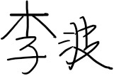

日期： 2026年5月 1 日 2026年5月1日

Harbin Engineering University
Thesis Authorization Statement

I fully understand the regulations of the university regarding the protection of intellectual property rights, that is, the intellectual property rights of the thesis work during the period of pursuing a degree at the university belong to Harbin Engineering University. Harbin Engineering University has the right to retain and submit copies of the thesis to relevant national departments or institutions. I allow Harbin Engineering University to include part or all of the content of the thesis in relevant databases for retrieval, and to use photocopying, microfilming, scanning, or other means of reproduction to preserve and compile this thesis. The full content of the thesis can be made available to the public. At the same time, I guarantee that any papers written after graduation based on the research topic of this degree thesis will indicate that the author's first affiliation is Harbin Engineering University. This statement is applicable to confidential theses after they are declassified.
This thesis can be submitted to relevant departments for preservation and compilation by Harbin Engineering University (□ immediately after the degree is granted □ 12 months after the degree is granted □ after declassification).

Author (Signature):  Supervisor (Signature): 

Date: 2026.5.1 Date:2026.5.1

ABSTRACT
Compressive sensing provides a reconstruction approach for recovering sparse signals from undersampled measurements. It has been widely studied in signal processing, communications and medical imaging.
Among the reconstruction algorithms, Orthogonal Matching Pursuit (OMP) is often used because of its simple implementation and low computational cost. However, the atom-selection step in OMP is strongly affected by the sensing matrix. Conventional sensing matrices are usually designed in a general form and do not fully reflect the structural characteristics of a specific dataset. In addition, many existing matrix optimization methods require iterative computation, which limits their use in real-time reconstruction tasks.
This thesis proposes a data-driven sensing matrix learning framework based on prior information. The proposed method learns an equivalent sensing matrix from similar sparse signals and uses it to guide the atom-selection process in OMP. Experiments on synthetic sparse signals, the MNIST handwritten digit dataset and real dynamic MRI sequences show that the proposed method improves support recovery and reconstruction quality while keeping the additional computational cost low.
Keywords: Compressive Sensing; Orthogonal Matching Pursuit; Sensing Matrix Learning

摘 要
压缩感知作为一种能从欠采样测量数据中恢复原始稀疏信号的重构方法，已在信号处理、通信和医学影像等领域得到广泛研究。
在压缩感知重构算法中，正交匹配追踪算法因实现简单、计算成本较低而被广泛采用。然而，OMP 的原子选择过程容易受到感知矩阵的影响。传统感知矩阵通常采用通用形式设计，难以充分反映特定数据集的结构特征。同时，许多现有矩阵优化方法依赖迭代计算，在实时重构任务中的应用受到一定限制。
针对上述问题，本文提出一种基于先验信息的数据驱动感知矩阵学习框架。该方法从相似稀疏信号中学习等效感知矩阵，并将其用于引导 OMP 的原子选择过程。在合成稀疏信号、MNIST 手写数字数据集和真实动态 MRI 序列上的实验结果表明，所提出方法能够提高支撑集恢复能力和重构质量，同时保持较低的额外计算成本。
关键词：压缩感知；正交匹配追踪；感知矩阵学习
Contents
ABSTRACT I
摘 要 II
I Introduction 1
1.1 Background and Significance 1
1.2 Problem Statement 2
1.3 Project Aim and Objectives 3
II Literature Review 4
2.1 Greedy Algorithms in Compressive Sensing 4
2.1.1 Matching Pursuit 4
2.1.2 Orthogonal Matching Pursuit 5
2.1.3 Limitations of OMP 5
2.2 Sensing Matrix Design 6
2.2.1 Random Sensing Matrices 7
2.2.2 Gram-Matrix Optimization 8
2.2.3 Metaheuristics and Manifold Approaches 9
2.2.4 Data-Driven Optimization 9
2.3 Research Gap and Chapter Summary 10
III Theoretical Framework and Methodology 11
3.1 Fundamentals of Compressive Sensing 11
3.2 Orthogonal Matching Pursuit 12
3.2.1 Introduction to OMP 12
3.2.2 Interference Mechanism 13
3.2.3 Concept of the Sensing Matrix 13
3.3 Problem Formulation and Objective Design 15
3.3.1 Statistical Objective Formulation 15
3.3.2 Theoretical Insights and Remarks 16
3.3.3 Hyperparameter Tuning 17
3.3.4 Fast Tuning Strategy 17
3.4 Low-Complexity Analytical Solution 18
3.5 Spatiotemporal Prior for Dynamic MRI 19
3.6 Algorithm Implementation 20
IV Experimental Results and Analysis 22
4.1 Simulation Setup and Metrics 22
4.1.1 Signal Generation and Parameters 22
4.1.2 Baselines and Metrics 22
4.2 Simulation Results 23
4.2.1 Hyperparameter Analysis 23
4.2.2 Performance Comparison 25
4.3 Evaluation on MNIST Dataset 28
4.3.1 Experiment Setup 28
4.3.2 Experiment Results 28
4.3.3 Correlation Between SRR and NRE 32
4.4 Evaluation on Real Dynamic MRI 33
4.4.1 Experiment Setup 33
4.4.2 Prior Length Analysis 33
4.4.3 Comparison Baselines 34
4.4.4 Reconstruction Results 34
V Conclusion 36
Reference 38
致谢 43
Acknowledgement 44

I Introduction

1.1 Background and Significance
Compressive sensing (CS) provides a mathematical framework for recovering sparse signals from a small number of linear measurements. Different from conventional sampling theory, CS shows that accurate reconstruction is still possible when the number of measurements is lower than the signal dimension, provided that the signal has a sparse representation and the measurement process satisfies suitable incoherence conditions (Candes, Romberg and Tao, 2006). This property is useful in applications where data acquisition is expensive, slow or physically constrained.
Magnetic resonance imaging (MRI) is one such application. In conventional MRI, image quality is closely related to the amount of acquired k-space data. If the sampling process is shortened directly, the reconstructed image may suffer from aliasing artefacts and loss of structural detail (Joseph, 1998; Hamilton, Franson and Seiberlich, 2017). Longer acquisition time may also increase patient discomfort and make the image more sensitive to motion artefacts (Jaspan, Fleysher and Lipton, 2015). Therefore, reducing the number of measurements while maintaining acceptable reconstruction quality has become an important problem in MRI reconstruction.
The suitability of CS for MRI is related to the sparse behaviour of medical images in transform domains. Although an MRI image is usually not sparse in the spatial domain, many of its transformed coefficients can be concentrated in a relatively small number of dominant components. For example, after applying the discrete cosine transform (DCT), the coefficient distribution of the brain MRI image in Fig. 1.1 becomes more concentrated than its original spatial-domain intensity distribution. This indicates that a large part of the image information can be represented by a limited number of significant transform coefficients.
Based on this sparsity property, CS-MRI can reduce the amount of acquired data and reconstruct the image from undersampled measurements (Donoho, 2006; Lustig, Donoho and Pauly, 2007). This makes CS a useful approach for accelerated MRI reconstruction, especially when reconstruction accuracy and computational efficiency need to be considered at the same time.
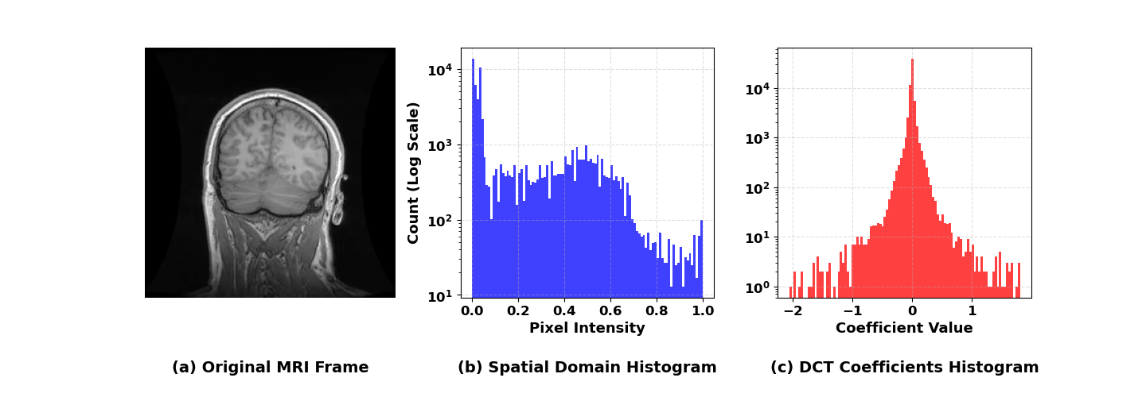
Fig. 1.1 Comparison of sparsity between the spatial domain and the DCT domain for the MRI image. (a) Original MRI grayscale frame. (b) Histogram of spatial domain pixel intensities. (c) Histogram of DCT coefficients.

1.2 Problem Statement
Among the reconstruction algorithms in compressive sensing, Orthogonal Matching Pursuit (OMP), as a greedy algorithm, is often used due to its relatively simple and computationally efficient. Instead of solving a full optimization problem, OMP builds the sparse support set step by step by selecting the atom that has the largest correlation with the current residual. This makes OMP attractive for real-time or near-real-time reconstruction tasks. However, the same greedy selection rule also makes OMP sensitive to early selection errors. Once an incorrect atom is selected, the following least-squares update is performed on an incorrect support set, and the error may continue to affect later iterations (Tropp, 2004).
The atom-selection reliability of OMP is closely related to the sensing or measurement matrix used during the matching step. Random matrices, pseudo-random matrices and Gram-matrix optimization methods have been used to reduce correlation between atoms. Although such matrices preserve a low atom selection error, however, they do not really consider the energy distribution and statistical structure of medical images for a certain kind of data (Tolouee, Alirezaie and Babyn, 2015). This means that their ability to fully use sparsity during reconstruction is still limited.
Therefore, it is desirable to develop a data-driven method which can learn an equivalent sensing matrix that fits the features of the specific data. Such a sensing matrix aims to reduce atom selection error, thereby improving the reconstruction accuracy of OMP while maintaining a low computational complexity that required for real-time MRI applications.

1.3 Project Aim and Objectives
The aim of this project is to develop a data-driven sensing matrix learning method for OMP-based compressive sensing reconstruction. The proposed method learns an equivalent sensing matrix from prior sparse signals and uses it only in the atom-selection stage of OMP.
- To formulate a sensing matrix learning problem that links prior sparse signals with the OMP atom-selection process.
- To derive a closed-form solution for the equivalent sensing matrix and reduce the computational cost of matrix inversion using matrix transformation techniques.
- To extend the proposed framework to dynamic MRI reconstruction by constructing a spatiotemporal prior from historical and neighboring image patches.
- To evaluate the proposed method using synthetic sparse signals, the MNIST image dataset and real dynamic MRI sequences, and to compare its performance with standard OMP and existing sensing matrix design methods.

II Literature Review

2.1 Greedy Algorithms in Compressive Sensing
In compressive sensing, signal reconstruction methods are commonly grouped into convex optimization methods and greedy pursuit algorithms. Convex optimization methods, such as basis pursuit, provide strong theoretical recovery guarantees, but their iterative optimization process can be computationally expensive when the signal dimension is large (Crespo Marques et al., 2019). This becomes a practical limitation in applications such as dynamic MRI, where reconstruction is expected to be completed within a short time window for each frame or image block. Greedy algorithms offer a more efficient alternative because they recover sparse signals by selecting atoms step by step, rather than solving a full convex optimization problem.
The main limitation appears in the matching step, where the algorithm must select the correct atom from a compressed residual at each iteration. Once an incorrect atom is included in the support set, the following residual update is affected, and the error may be propagated to later iterations (Li et al., 2020). For this reason, the matching step should be treated as the central part of OMP reconstruction.

2.1.1 Matching Pursuit
Matching Pursuit (MP) is one of the earliest greedy algorithms for sparse approximation. Its basic idea is to approximate a signal by repeatedly selecting the atom that has the largest inner product with the current residual. In each iteration, the selected atom explains part of the residual energy, and the residual is then updated for the next selection step (Mallat and Zhang, 1993). The main weakness of MP is that its residual update does not explicitly enforce orthogonality with respect to all previously selected atoms. As a result, the contribution of a selected atom may still remain in the residual, which can lead to repeated or inefficient atom selection. This problem is particularly significant when the atoms in the measurement matrix are highly correlated. In such cases, several atoms may produce similar correlation responses, making it difficult for the algorithm to identify the correct support element. MP is therefore efficient, but it can become unstable when several atoms give similar correlation responses.

2.1.2 Orthogonal Matching Pursuit
OMP improves MP by introducing an orthogonal projection step after each atom selection. Instead of updating the residual only according to the latest selected atom, OMP recomputes the least-squares solution over all selected atoms and updates the residual accordingly. This ensures that the residual is orthogonal to the subspace spanned by the selected atoms, thereby reducing repeated selection and improving convergence stability (Pati, Rezaiifar and Krishnaprasad, 1993). This orthogonal projection mechanism also improves the convergence speed and reconstruction accuracy of the algorithm (Zhang et al., 2015), making it suitable for large-scale data processing and real-time signal reconstruction scenarios (Rabah et al., 2015; Kulkarni and Mohsenin, 2017).
Several variants have been developed to further improve greedy recovery. For instance, CoSaMP enhances OMP by identifying multiple atoms (typically 2$k$) in each iteration and keeping the best $k$ atoms through a pruning step (Needell and Tropp, 2009). This strategy improves recovery robustness, but it also requires prior knowledge of the sparsity level and introduces additional sorting and pruning operations. (Ravazzi, 2018). Similarly, Stagewise Orthogonal Matching Pursuit (StOMP) selects multiple atoms through a thresholding rule rather than selecting only one atom at a time (Donoho et al., 2012). This can improve speed in some large-scale problems, but the threshold parameter must be carefully chosen (Zhao, 2023). If the threshold is too high, true atoms may be missed; if it is too low, false atoms may be included. These variants show that modifying the selection strategy can improve recovery, but they also introduce new choices such as sparsity level, pruning size or threshold value.

2.1.3 Limitations of OMP
The main limitation of OMP comes from its greedy selection rule. At each iteration, OMP selects the atom with the largest correlation with the current residual. This rule is reliable only when the correct atom produces a clearly stronger response than all incorrect atoms. However, when the columns of the measurement matrix are highly correlated, an incorrect atom may produce a correlation value close to or even larger than that of the true atom. This may cause OMP to select the wrong support index.
This problem is commonly described using mutual coherence. Mutual coherence measures the maximum normalized inner product between two different columns of a matrix. A smaller value indicates that the columns are more distinguishable, while a larger value means that different atoms are more likely to interfere with each other during the matching process. From this perspective, mutual coherence is not only a mathematical property of the matrix, but also a direct indicator of the probability of incorrect atom selection in OMP (Emadi et al., 2018). The influence of coherence can also be connected to the recovery condition of OMP. In general, successful sparse recovery requires the correct atoms to dominate the correlation response. When the coherence is high, the accumulated interference from non-support atoms increases, and the selection boundary between correct and incorrect atoms becomes less clear. Since standard OMP does not include a backtracking mechanism, an early wrong selection cannot be removed automatically. The error is then carried into the least-squares update and affects the subsequent residual, which may finally lead to degraded support recovery and larger reconstruction error (Tropp and Gilbert, 2007).
This limitation explains why sensing matrix design is important in OMP-based reconstruction. If the sensing matrix can reduce the correlation interference during the matching step, the probability of correct atom selection can be improved. For this reason, the present thesis focuses on learning an equivalent sensing matrix that improves the atom-selection stage while keeping the original measurement process unchanged.

2.2 Sensing Matrix Design
The discussion in Section 2.1 shows that the performance of OMP is strongly affected by the correlation structure of the matrix used in the matching step. When different atoms have similar responses to the residual, OMP may select an incorrect support index, and this error cannot be removed in later iterations. Therefore, one possible way to improve OMP is to modify the matrix used for atom selection.
In the standard OMP formulation, the same measurement matrix $Φ$ is used for both atom selection and coefficient estimation. Schnass and Vandergheynst (2008) proposed a different view by introducing a separate sensing matrix $Ψ$. Under this framework, $Ψ$ is used only in the matching step, while $Φ$is still retained for the least-squares reconstruction stage.
Existing sensing matrix design methods can be discussed from four main directions: random matrix construction, structured or hardware-friendly random matrices, Gram-matrix-based optimization, and data-driven prior-based methods.

2.2.1 Random Sensing Matrices
Random matrices are the most commonly used matrices in early compressive sensing studies. Gaussian and Bernoulli matrices are typical examples. A Gaussian matrix contains entries sampled from a continuous normal distribution, whereas a Bernoulli matrix is usually formed by discrete random values. Their major advantage is that they can provide good incoherence properties with high probability, which explains why they are widely used in theoretical analyses of sparse recovery (Krahmer and Rauhut, 2014). However, random matrices are not always convenient in engineering systems. A fully random matrix may require large storage when the signal dimension is high. It may also be difficult to implement efficiently in hardware because the matrix does not have an exploitable structure (Do et al., 2012; Shahbazi, Taban and Abouei, 2019). For this reason, deterministic and pseudo-random constructions have been proposed. These methods reduce storage by generating matrix entries from deterministic rules or initial seeds, rather than storing every element of the matrix.
Although pseudo-random matrices reduce memory requirements, they also introduce new restrictions. Some constructions require the matrix size to satisfy specific number-theoretic conditions. For example, certain deterministic constructions are only valid under particular dimensional settings, such as prime-related or square-number constraints (Naidu, Jampana and Sastry, 2016). This becomes inconvenient when the image or patch size is fixed by an application.
Structured random matrices provide another compromise. Partial Fourier matrices are especially relevant to MRI because MRI data are naturally acquired in the frequency domain. Compared with fully random Gaussian matrices, Fourier-based sampling is more compatible with the acquisition mechanism of MRI systems. Nevertheless, from the viewpoint of OMP, these matrices are still mostly data-independent. They are usually designed to satisfy general incoherence requirements, rather than to reflect the coefficient distribution of a specific dataset. As a result, they may still produce incorrect atom selection when the sampling rate is very low or when the sparse coefficients are strongly concentrated in certain frequency regions.
For the present thesis, random and structured matrices are therefore useful as baselines, but they do not fully address the main problem. They are useful as general baselines, but they do not use information from the target signal class. This leaves room for methods that control the matrix correlation more directly.

2.2.2 Gram-Matrix Optimization
A more direct way to improve atom selection is to reduce the correlation between atoms. In this type of method, the Gram matrix is usually used to describe the inner-product relationship between matrix columns. Ideally, the diagonal elements of the Gram matrix should remain large, while the non-diagonal elements should be as small as possible. This is because the diagonal terms represent the response of an atom to itself, whereas the non-diagonal terms represent interference from other atoms. In this area, Elad (2007) proposed a method for matrix optimization. His approach involves iterative optimization of the non-diagonal elements of the Gram matrix, gradually bringing it closer to the Welch bound, which represents the theoretical limit of minimum correlation, thereby reducing the correlation between columns of the sensing matrix. This method enables the construction of an optimized matrix and thus increases the success rate of OMP in sparse signal recovery. Building on this idea, Schnass and Vandergheynst (2008) further connected this idea with OMP by introducing a sensing matrix for the matching stage. This is particularly relevant to this thesis because it shows that the atom-selection process can be improved without replacing the OMP algorithm itself. In recent years, Gram matrix optimization frameworks show the aim of accelerating convergence and further reducing coherence. For example, Yi et al. (2025) combines alternating minimization with momentum gradient descent algorithms, resulting in faster convergence speeds.
However, Gram-matrix optimization also has limitations. First, it is usually an iterative procedure. Each iteration requires matrix updates, thresholding or projection operations, which may increase computational cost. Second, the optimization target is mainly mathematical. It aims to reduce coherence in a general sense, but it does not necessarily consider which atoms are more likely to appear in a particular dataset. Third, the objective function for optimizing the Gram matrix is inherently non-convex (Ko and Li, 2022), which can lead to the algorithm getting stuck in suboptimal local minima and thus failing to reach the theoretical limits.

2.2.3 Metaheuristics and Manifold Approaches
To avoid the local limitations of the conventional optimization, some studies formulate sensing matrix design as a more general global optimization problem. Metaheuristic algorithms search the matrix parameter space by using population-based or evolutionary strategies. Their advantage is that they do not rely heavily on gradient information and can explore a wider solution space (Parkale and Nalbalwar, 2021). Another direction is manifold optimization. In this type of method, the matrix is constrained to lie on a specific geometric space, such as a space with orthogonality or normalization constraints. This can make the optimization process mathematically more controlled and can help maintain desirable structural properties of the matrix (Mohades, Mohades and Zamanian, 2025).
Despite these advantages, such methods are not well suited to real-time reconstruction. Metaheuristic algorithms may require many generations or repeated population evaluations before convergence. Manifold methods may involve specialized operations such as Riemannian gradients, retractions and projections. These operations are acceptable for offline matrix design, but they are difficult to justify when the sensing matrix needs to be updated frequently from local prior data. In this thesis, these methods are treated mainly as reference points. Their optimisation ability is useful, but their online cost is not consistent with the intended real-time reconstruction setting.

2.2.4 Data-Driven Optimization
More recent studies have attempted to incorporate prior information into compressive sensing reconstruction. Instead of designing a matrix solely from mathematical coherence criteria, these methods use training data, historical signals or support statistics to guide the reconstruction process. For example, Reweight-OMP combines a weighted matrix derived from training data to adjust and optimize the weighted matrix based on the statistical frequency of atom usage (Huang et al., 2011). Similarly, probability-based OMP directly adjusts the matching process in the OMP algorithm. By integrating the prior probabilities of each atom belonging to the true support into the inner product calculation, the algorithm is guided to prioritize atoms with high historical correlations. (Jiang et al., 2020).
Li et al. (2017) introduced a sampling matrix design method based on prior information, where historical data are used to make the measurement process more consistent with the target signal structure. This demonstrates the value of data-driven matrix design in compressive sensing. However, this idea is not straightforward to apply in MRI. The sampling pattern in MRI is constrained by the gradient system and the k-space acquisition trajectory, so it is difficult to update the physical sampling matrix dynamically for each frame or patch (Jaspan, Fleysher and Lipton, 2015; Safari et al., 2026). For this reason, the present thesis focuses on learning a sensing matrix rather than changing the measurement matrix. The learned matrix is only used in the OMP matching step, allowing prior information to be used without altering the fixed acquisition process.

2.3 Research Gap and Chapter Summary
The reviewed studies show that sensing matrix design has moved from general random matrices to optimization-based and data-driven methods. However, each approach still has limitations for OMP-based real-time reconstruction. Random and structured matrices are easy to use, but they do not reflect the statistical structure of a specific dataset. Gram-matrix optimization can reduce coherence, but it often relies on iterative computation and treats all atom correlations in a general way. More advanced optimization methods may provide better search ability, but their computational cost is usually too high for online reconstruction. The gap here lies in the difficulty of achieving both high reconstruction accuracy and low computational cost in real-time applications.
Based on this gap, this thesis proposes a data-driven sensing matrix learning method for OMP. The learned matrix is used only in the atom-selection stage, while the original measurement matrix remains unchanged for reconstruction. In this way, the method aims to improve reconstruction accuracy while maintaining compatibility with fixed MRI sampling and low computational cost.

III Theoretical Framework and Methodology

3.1 Fundamentals of Compressive Sensing
Let $x∈R^{n}$denote a real-valued discrete signal. In many imaging problems, $x$ is not sparse in the spatial domain, but it may have a sparse representation after being projected onto a suitable transform basis, such as wavelet, DCT or Fourier basis.
Assume a basis matrix $D∈R^{n×n}$ such that the signal $x$ can be represented as:
 | $x= Ds$, | (1)
where $s∈R^{n}$ is the coefficient vector of the signal $x$ in the transform domain $D$. If the coefficient vector $s$ contains only $k$non-zero entries with $k≪n$, then $x$ is regarded as $k$-sparse under the transform basis $D$.
A lower-dimensional observation $y$ is obtained through linear projection using a sampling matrix $P∈R^{m×n}$. Here, $m$ represents the number of measurements.
In practical acquisition, the measurements are affected by noise. The observation model can therefore be written as:
 | $y=Px+e=PDs+e$, | (2)
where $e∈R^{m×1}$ represents the additive measurement noise.
Let $Φ=PD$ , where $Φ∈R^{m×n}$ is called the measurement matrix. The above equation can be simplified to the linear system for the sparse coefficient vector $s$:
 | $$y=Φs+e.$$ | (3)
Since $m<n$, the system is underdetermined, meaning that the measurements alone are insufficient to determine a unique solution. The sparsity assumption provides an additional constraint. Under this assumption, signal recovery can be formulated as the following $l_{0}$-minimisation problem. (Candes & Tao, 2005):
 | $\min_{s}∥s∥_{0}\text{s.t.}∥y-Φs∥_{2}≤ϵ$, | (4)
where $∥s∥_{0}$represents the number of non-zero elements in $s$, and $ϵ$ is the noise tolerance. Although the $l_{0}$ formulation directly describes sparsity, solving it requires a combinatorial search over possible support sets. This makes the problem computationally infeasible for high-dimensional signals. Therefore, researchers usually convert this into $l_{1}$ norm minimization or use greedy algorithms to reconstruct the sparse signal from its measurement.

3.2 Orthogonal Matching Pursuit

3.2.1 Introduction to OMP
Before presenting the OMP, several terms used in sparse recovery are defined. For example, the individual column vectors of the matrix are called atoms. The support set is defined as the index set of the atoms that correspond to the non-zero coefficients of the underlying sparse signal.
OMP follows this idea by constructing the support set one atom at a time (Pati, Rezaiifar, and Krishnaprasad, 1993). The algorithm begins by initializing the residuals as observation vectors and setting the support set to empty. With each iteration, algorithm calculates the correlation between the current residual and all the atoms in the measurement matrix. Then select the atom with the highest residual correlation and add it to the support set. Next, a least squares orthogonal projection is carried out to estimate the best coefficient for all currently selected atoms. This orthogonal projection removes the contribution of the selected atoms from the residual, reducing the chance of repeated selection in later iterations.
The pseudo-code of the OMP algorithm is as follows:
Tab. 3.1 Pseudo-code for the OMP algorithm.
Algorithm 1 Orthogonal Matching Pursuit (OMP)
Input: Observation $y,$ measurement matrix Φ, sparsity $k.$
Output: Estimated signal $\hat{s},$ support set $Λ$.
- Initialization: $r= y, Λ= ∅$.
- Repeat $k$ times:
- $λ = argmax_{j} \left|Φ_{j}^{T}r\right|,$
- $Λ = Λ ∪ \left\{λ \right\},$
- ${\hat{s}}_{Λ}={\left(Φ_{Λ}^{T}Φ_{Λ}\right)}^{-1}Φ_{Λ}^{T}y,$
- $r=y-Φ_{Λ}{\hat{s}}_{Λ},$
- $s_{\hat{Λ}}=0, s_{Λ}={\hat{s}}_{Λ}$.

3.2.2 Interference Mechanism
Although OMP provides an efficient greedy solution for sparse signal recovery, its inherent greedy nature also imposes a key limitation: the process of selecting atoms is highly sensitive to the coherence of the measurement matrix Φ. When two or more atoms are highly correlated, the matching step may no longer clearly distinguish the true atom from competing atoms. Mathematically, the similarity between atoms in the measurement matrix Φ is characterized by the coherence (Tropp 2004), defined as
 | $$μ(Φ)=\underset{i≠j}{max⁡}\frac{∣⟨φ_{i},φ_{j}⟩∣}{∥φ_{i}∥_{2}∥φ_{j}∥_{2}}.$$ | (5)
The cumulative coherence is given by
 | $$μ_{1}(k,Φ)=\underset{∣J∣=K}{max⁡}\underset{i∉J}{max⁡}\sum_{j∈J}{∣⟨}φ_{i},φ_{j}⟩∣.$$ | (6)
This coherence measure can be linked to the exact recovery condition of OMP.
 | $μ_{1}\left(k\right)+μ_{1}\left(k-1\right)<1$. | (7)
However, when the measurement matrix is highly coherent and this mathematical condition is violated, the interference mechanism takes over. In the ideal case, the signal $y$ admits a $k$-sparse representation over $Φ$. Yet, during the matching stage of OMP, the inner product between the residual $r$ and a non-support atom accumulates false projection values from the true support atoms via the $\sum{∣\left\langle φ_{i},φ_{j}\right\rangle ∣}$ term defined in Equation (6). If this accumulated interference is large enough, the inner product of a non-support atom surpasses that of a true support atom, leading to an incorrect atom selection.
Since standard OMP does not include a backtracking step, an incorrect atom selected at an early iteration remains in the support set; this error may accumulate through later iterations until the reconstruction finally fails (Tropp and Gilbert, 2007). The reconstruction performance of OMP is therefore strongly affected by the coherence structure of the matrix used for matching. This motivates the use of a modified sensing matrix to reduce interference during atom selection.

3.2.3 Concept of the Sensing Matrix
To reduce the influence of highly coherent atoms, Schnass (2008) introduced a sensing matrix $Ψ$ as a preconditioning matrix for the OMP matching step. In this framework, the original measurement matrix $Φ$is retained for coefficient estimation, while the sensing matrix $Ψ$ is used only for atom selection. The atom selection step in OMP is modified from
 | $$λ = argmax_{j} \left|Φ_{j}^{T}r\right|$$ | (8)
to
 | $$λ= argmax_{j} \left|Ψ_{j}^{T}r\right|,$$ | (9)
where $Ψ_{j}$ denotes the $j$-th column of the sensing matrix Ψ. Meanwhile, the reconstruction step remains unchanged, and the estimated sparse coefficients ${\hat{s}}_{Λ}$ are still computed using $Φ_{Λ}$ as
 | $${\hat{s}}_{Λ}={\left(Φ_{Λ}^{T}Φ_{Λ}\right)}^{-1}Φ_{Λ}^{T}y,$$ | (10)
where $Λ$ denotes the current active support set, $Φ_{Λ}$ represents the selected sub-dictionary matrix composed of the columns indexed by $Λ$, and ${\hat{s}}_{Λ}$ is the estimated sparse coefficient vector corresponding to the currently selected atoms.
Sensing matrix Ψ improves performance by relaxing the concept of cumulative cross-coherence. Instead of relying on the cumulative coherence of Φ, the recovery condition now depends on the cross-coherence between Φ and Ψ, defined as:
 | $${\tilde{μ}}_{1}(k,Φ,Ψ)=\underset{∣J∣=K}{max⁡}\underset{i∉J}{max⁡}\sum_{j∈J}{∣⟨}ψ_{i},φ_{j}⟩∣.$$ | (11)
In addition, the minimal gain between corresponding atoms is defined as
 | $$β(Φ,Ψ)=\underset{i}{min⁡}∣⟨ψ_{i},φ_{i}⟩∣.$$ | (12)
Under this framework, the recovery condition of OMP is relaxed from
 | $$μ_{1}\left(k\right)+μ_{1}\left(k-1\right)<1$$ | (13)
to
 | ${\tilde{μ}}_{1}\left(k\right)+{\tilde{μ}}_{1}\left(k-1\right)<β$. | (14)
Since the sensing matrix Ψ can be designed so that its cross-coherence ${\tilde{μ}}_{1}$ is less than the original cumulative coherence $μ_{1}$, the original atomic selection conditions become easier to meet. Therefore, the OMP algorithm can improve the accuracy of atomic selection.
In terms of implementation, this modification only changes the inner-product calculation used for matching, as it only replaces Φ with Ψ in the inner product calculation. The measurement matrix used for reconstruction is not changed, which is important for MRI applications where the physical sampling process is constrained by the acquisition system.

3.3 Problem Formulation and Objective Design
The next step is to define how the sensing matrix should be learned from prior sparse signals. The aim is to make the matching response more consistent with the underlying sparse coefficients.

3.3.1 Statistical Objective Formulation
Assume that a group of prior sparse signals is available from the same application scenario. These samples are arranged into the data matrix:
 | $X=\left[x_{1}^{\left(v\right)},x_{2}^{\left(v\right)},…,x_{l}^{\left(v\right)}\right]∈R^{n×l}$, | (15)
where $n$ denotes the dimension of each signal vector or vectorized image patch, and $l$ denotes the number of training samples.
Given a sparse signal $x$ from the training dataset, its low-dimensional measurements obtained through the measurement matrix are $Φx$. When the sensing matrix $Ψ$ is used in the OMP matching stage, the corresponding inner-product correlation vector can be expressed as $Ψ^{T}\left(Φx\right)$. This correlation output $Ψ^{T}\left(Φx\right)$ is not used as the final reconstruction. Instead, it serves as a proxy response for the OMP matching step, indicating which atoms are more likely to belong to the true support set. The objective term seeks to optimize $Ψ$ so that this proxy signal produces the sharpest possible peaks at the true support indices.
Based on this idea, the sensing matrix is learned by minimizing the mismatch between the proxy response and the target sparse coefficients:
 | $\min_{Ψ}{\frac{1}{l}\sum_{i=1}^{l}{∥Ψ^{T}Φx_{i}-x_{i}∥_{2}^{2}}+τ∥Ψ∥_{F}^{2}}$. | (16)
The first term in the objective function ensures that the compressed and aliased measurements $Φx_{i}$, when projected by $Ψ^{T}$, can best approximate the original high-dimensional sparse features $x_{i}$. The second term is the Tikhonov regularization term, ensuring numerical stability and improving generalization to unseen data, with $τ>0$being the regularization parameter. The optimization problem can be formulated as follows:
 | $\underset{Ψ}{min⁡}\frac{1}{l}∥Ψ^{T}ΦX-X∥_{F}^{2}+τ∥Ψ∥_{F}^{2}$, | (17)
and let $J\left(Ψ\right)$ be the objective function in equation (17).
Theorem 1. The objective function in equation (17) is strictly convex with respect to the sensing matrix $Ψ$ for any regularization parameter $τ>0$.
Proof. The objective $J\left(Ψ\right)$is quadratic with respect to $Ψ$, so its convexity can be checked from the coefficient matrix of the second-order term.
The first-order derivative of $J\left(Ψ\right)$ with respect to $Ψ$ can be derived as:
 | $\frac{∂J\left(Ψ\right)}{∂Ψ}=\frac{2}{l}\left(ΦXX^{T}Φ^{T}\right)Ψ-\frac{2}{l}\left(ΦXX^{T}\right)+2τΨ$. | (18)
The matrix associated with this second-order term is:
 | $H=\frac{1}{l}ΦXX^{T}Φ^{T}+{τI}_{m},$ | (19)
where $I_{m}$ represents the $m×m$ identity matrix. The term $1/lΦXX^{T}Φ^{T}$is positive semi-definite. Adding ${τI}_{m}$with $τ>0$ makes the matrix strictly positive definite.
Hence, the objective is strictly convex in $Ψ$, and the minimiser is unique.
The closed-form solution can then be obtained by setting the gradient with respect to $Ψ$ equal to zero.
 | $\frac{∂J\left(Ψ\right)}{∂Ψ}=\frac{2}{l}\left(ΦXX^{T}Φ^{T}\right)Ψ-\frac{2}{l}\left(ΦXX^{T}\right)+2τΨ=0$. | (20)
Rearranging the resulting normal equation gives:
 | $$Ψ=(ΦXX^{T}Φ^{T}+{lτI}_{m})^{-1}ΦXX^{T}.$$ | (21)

3.3.2 Theoretical Insights and Remarks
Remark 1: When the number of training samples is sufficiently large, the objective is influenced by the second-order statistics of the data. As a result, directions with larger variance have a stronger effect on the learned sensing matrix.
To have a better understanding, we can evaluate the expectation of the objective function:
 | $\lim_{l→∞}{\frac{1}{l}\sum_{i=1}^{l}{∥Ψ^{T}Φx_{i}-x_{i}∥_{2}^{2}}}=E\left[∥Ψ^{T}Φx-x∥_{2}^{2}\right]$. | (22)
Using the cyclic property of trace, the expected error can be rewritten as:
 | $$E\left[∥Ψ^{T}Φx-x∥_{2}^{2}\right]=E\left[tr\left(Ψ^{T}Φx-x\right){\left(Ψ^{T}Φx-x\right)}^{T}\right]$$
 | $$=\text{tr}\left(\left(Ψ^{T}Φ-I\right) E[{xx}^{T}] (Ψ^{T}Φ-I)^{T}\right)$$
 | $=\text{tr}\left(\left(Ψ^{T}Φ-I\right) C (Ψ^{T}Φ-I)^{T}\right)$, | (23)
where $C=E\left[{xx}^{T}\right]$ represents the second-order matrix of the data.
This formula reveals that the data is implicitly weighted by its covariance structure. By doing this, the sensing matrix we produced can naturally focus on the main variation directions, which relate to the main eigenvalues of $C$.
Remark 2: The introduce of the Tikhonov regularization term can be interpreted from the noise level when the training data is infinitely large.
When we add noise into the expectation in equation (22), we can get:
 | $$E\left[∥Ψ^{T}\left(Φx+e\right)-x∥_{2}^{2}\right]=E\left[∥\left(Ψ^{T}Φx-x\right)+Ψ^{T}e)∥_{2}^{2}\right].$$ | (24)
Assuming that the noise $e$ has zero mean and no correlated with the signal $X$, the cross terms will disappear under expectation. Then the expression can be simplified as:
 | $E\left[∥Ψ^{T}Φx-x∥_{2}^{2}\right]+\text{tr}\left(Ψ^{T}E\left[ee^{T}\right]Ψ\right)$. | (25)
Because the noise has a variance of $σ^{2}$, we have $E\left[ee^{T}\right]=σ^{2}I$, which leads to:
 | $E\left[∥Ψ^{T}\left(Φx+e\right)-x∥_{2}^{2}\right]=E\left[∥Ψ^{T}Φx-x∥_{2}^{2}\right]+σ^{2}∥Ψ∥_{F}^{2}$. | (26)
We can see that the noise naturally brings a Frobenius norm penalty to the sensing matrix $Ψ$; in other words, the noise robustness is closely linked to the regularization, and this directly proves why we must include this regularization term.

3.3.3 Hyperparameter Tuning
The regularization parameter $τ$ controls how strongly the learned matrix follows the prior samples. In this work, $τ$ is selected by grid search on a validation set. Let $V=\left[x_{1}^{\left(v\right)},x_{2}^{\left(v\right)},…,x_{p}^{\left(v\right)}\right]$denote a validation dataset consisting of $p$ signals. A discrete candidate set of regularization parameters is defined as $S=\left\{τ_{1},τ_{2},…,τ_{q}\right\}$consisting of $q$ signals.
For each candidate $τ∈S$, the corresponding sensing matrix $Ψ\left(τ\right)$is constructed using only the training dataset, based on the closed-form solution derived in the previous section.
For each candidate value, the sensing matrix is built from the training set and evaluated on validation samples using the proxy reconstruction error. The optimal parameter $τ_{\text{opt}}$is selected by minimizing this error, which can be formulated as:
 | $τ_{\text{opt}}=arg⁡\underset{τ∈S}{min⁡}\sum_{i=1}^{q}{{∥XX^{T}Φ^{T}{\left(ΦXX^{T}Φ^{T}+lτI\right)}^{-1}Φx_{i}^{\left(v\right)}-x_{i}^{\left(v\right)}∥}_{2}^{2}}$. | (27)

3.3.4 Fast Tuning Strategy
Direct grid search is expensive because the matrix inverse must be recomputed for every candidate value of $τ$.
For each candidate value of $τ$, directly computing the $(ΦXX^{T}Φ^{T}+l{τI}_{m})^{-1}ΦXX^{T}$ requires $O\left(mnl\right)$ operations.
To improve the efficiency, we adopted a strategy based on eigen-decomposition. Because the matrix $ΦXX^{T}Φ^{T}$is symmetric and positive semi-definite and remains constant with respect to $τ$. Therefore, we can decompose it once before doing the grid search
 | $$ΦXX^{T}Φ^{T}=UΛU^{T},$$ | (28)
where $U∈R^{m×m}$is an orthogonal matrix of eigenvectors, and$Λ=diag\left(λ_{1},λ_{2},…,λ_{m}\right)$contains the corresponding eigenvalues.
By putting this decomposition back into the closed-form expression, we can efficiently compute the sensing matrix as
 | $$Ψ(τ)=U(Λ+lτI_{m})^{-1}U^{T}ΦXX^{T}.$$ | (29)
Even though the overall computational complexity to build the sensing matrix in equation (29) is still $O\left(mnl\right)$, the most computationally intensive components $ΦXX^{T}Φ^{T}$ is evaluated only once rather than repeatedly. After this decomposition, different values of $τ$can be tested by changing only the diagonal term, which reduces repeated matrix-inversion operations.

3.4 Low-Complexity Analytical Solution
Equation (21) requires inverting a high-dimensional matrix with computational complexity $O\left(mnl\right)$. To overcome this bottleneck, we introduce the push-through identity, which is an important corollary of the Woodbury matrix inversion lemma (Petersen and Pedersen, 2012). Suppose matrix of $l$ prior signals are extracted:
 | $X∈R^{n×l}$. | (30)
Then we let:
 | $A=ΦX∈R^{m×l}$, | (31)
representing the projection of prior signals into the observation domain. So, the regularized analytical solution in (21) can then be rewritten as
 | $Ψ=(AA^{T}+lτI_{m})^{-1}AX^{T}$. | (32)
According to the push-through identity theorem, for any matrix $A$and scalar $τ$, the following transformation holds:
 | $(AA^{T}+lτI_{m})^{-1}A=A(A^{T}A+lτI_{l})^{-1}$. | (33)
By applying this identity, we effectively “push” the matrix inversion from the left side in the high-dimensional observation space to the right side in the low-dimensional prior feature space. Consequently, the equivalent sensing matrix can be expressed as
 | $Ψ=A(A^{T}A+lτI_{l})^{-1}X^{T}$. | (34)
Let the inner Gram matrix be
 | $$G=A^{T}A∈R^{l×l}$$ | (35)
and define
 | $Q=(G+lτI_{l})^{-1}∈R^{l×l}$. | (36)
The final simplified solution becomes
 | $Ψ=AQX^{T}$. | (37)
When it comes to real-time dynamic MRI, the number of historical samples $l$ is usually quite limited, which basically satisfies $l≪n$. Based on this condition, the transformation avoids the prohibitive computational cost of $O\left(mnl\right)$, reducing it to a much lower complexity of $O\left(ml^{2}\right)$.

3.5 Spatiotemporal Prior for Dynamic MRI
The proposed sensing matrix learning method depends on the prior signal matrix $X$. In dynamic MRI, previous frames should not be treated equally, because anatomical structures change over time (Jung et al., 2009). Older frames may become less relevant to the current frame and may even mislead the sensing matrix learning process. At the same time, neighbouring image patches usually share similar local structures after block division, which provides useful spatial prior information.
Therefore, this thesis constructs $X$ using a joint spatiotemporal prior. Recent historical patches are given higher weights through an exponential decay mechanism, while neighbouring patches are also included to improve local structural consistency. This design makes the prior matrix more adaptive to dynamic MRI reconstruction.
1) Temporal Prior with Exponential Decay
Let $x_{i,t}$ denote the vectorized image patch at spatial location $i$and time $t$. For the temporal prior, patches from the same spatial location are collected from the previous $T$ frames. Since older frames may be less consistent with the current structure, an exponential decay weight is assigned to each historical patch:
 | $w_{h}=e^{-γh},h=1,2,…,T$, | (38)
where $γ$ is the decay rate and $h$represents the temporal delay. The temporally weighted prior matrix is defined as:
 | $X_{temp}=[w_{1}x_{i,t-1}, w_{2}x_{i,t-2}, …, w_{T}x_{i,t-T}]$. | (39)
With this weighting strategy, recent frames contribute more strongly to the prior matrix, while the influence of older frames is gradually reduced. This allows the learned sensing matrix to follow the temporal changes in the MRI sequence more effectively.
2) Spatial Neighborhood Prior
Temporal information alone may be insufficient when the image structure changes rapidly or when only a short history is available. Therefore, spatially neighboring patches are also included in the dataset. Let $N(i)$ denote the neighborhood of patch $i$. The spatial prior is constructed as:
 | $X_{spat}=[x_{j,t}]_{j∈N(i)}$. | (40)
This spatial component uses the local similarity between adjacent patches and helps maintain structural consistency within the same frame. It is particularly useful at the early stage of reconstruction, when only limited temporal information is available and the algorithm has not yet accumulated sufficient historical frames.
3) Joint Spatiotemporal Construction
The final prior matrix combines the temporal and spatial components:
 | $X_{i,t}=[X_{spat}, X_{temp}]∈R^{n×l}$. | (41)
Through this construction, the prior matrix contains both short-term temporal information and local spatial information. It therefore provides a more suitable input for sensing matrix learning in dynamic MRI reconstruction.

3.6 Algorithm Implementation
The proposed reconstruction process consists of two main stages. In the first stage, the measurement matrix $Φ$and the prior signal matrix $X$ are used to construct the equivalent sensing matrix $Ψ$. The push-through identity is applied in this step to avoid direct inversion of a high-dimensional matrix and reduce computational cost.
In the second stage, the learned sensing matrix $Ψ$ is used in the atom-selection step of OMP. The original measurement matrix $Φ$is still used for the least-squares coefficient update and final reconstruction. Therefore, the proposed method changes the matching process of OMP, but does not change the physical measurement model.
The complete procedure is summarized in the following pseudocode.
Tab. 3.2 Pseudo-code for the Proposed OMP algorithm.
Algorithm 2 Proposed Sensing Matrix Design and OMP Reconstruction
Input: Observation $y,$ measurement matrix Φ, sparsity $k,$ signal matrix $X,$ regularization parameter $τ$.
Output: Estimated signal $\hat{s},$ support set $Λ$.
- Phase 1: Sensing Matrix Learning
- $A=ΦX,$
- $G=A^{T}A,$
- $Q={\left(G+lτI\right)}^{-1},$
- $Ψ=AQX^{T}$.
- Phase 2: Signal Reconstruction via OMP
- Initialization: $r= y, Λ= ∅$.
- Repeat $k$ times:
- $λ = argmax_{j} \left|Ψ_{j}^{T}r\right|$,
- $Λ = Λ ∪ \left\{λ \right\},$
- ${\hat{s}}_{Λ}={\left(Φ_{Λ}^{T}Φ_{Λ}\right)}^{-1}Φ_{Λ}^{T}y,$
- $r=y-Φ_{Λ}{\hat{s}}_{Λ},$
- $s_{\hat{Λ}}=0, s_{Λ}={\hat{s}}_{Λ}$.

IV Experimental Results and Analysis
This chapter evaluates the proposed sensing matrix learning method on three types of data: synthetic sparse signals, MNIST images and real dynamic MRI sequences. Sections 4.1 and 4.2 first use synthetic sparse signals to check the basic recovery behavior of the method. Section 4.3 uses the MNIST dataset for further evaluation. Section 4.4 then applies the method to dynamic MRI sequences to examine its behavior in real time scenarios.

4.1 Simulation Setup and Metrics

4.1.1 Signal Generation and Parameters
This section uses synthetic sparse signals to test whether the learned sensing matrix improves OMP support recovery under controlled conditions. The signals are generated using power-law decaying coefficients, retaining the top $k$largest coefficients and setting the rest to zero. The magnitudes of the retained coefficients follow a power-law decay with an exponent of 1. This setting gives an image-like sparse signal model, where a small number of dominant coefficients carry most of the signal energy.
In the basic simulation setting, the sparse signal length was $n=256$, the number of measurements was $m=64$, the sparsity level was $k=30$, the learning length was $l=100$, and the regularisation parameter was fixed at $τ=1$. The measurement matrix $Φ$was generated as a Gaussian random matrix. Each entry was independently sampled from a standard normal distribution, and each column was normalized before reconstruction.

4.1.2 Baselines and Metrics
Two comparison methods were used in the synthetic experiments. The first was standard OMP, where no separate sensing matrix is learned and $Ψ=Φ$. This baseline shows the recovery performance obtained directly from the original measurement matrix. The second comparison method was the sensing matrix design approach of Schnass and Vandergheynst (2008), which reduces cross-correlation by alternating projection.
Performance was evaluated using two measures: support recovery rate (SRR) and normalized reconstruction error (NRE). SRR records the proportion of true support indices correctly recovered by OMP. It is defined as:
 | $$SRR=\frac{∣\hat{Λ}∩Λ∣}{∣Λ∣},$$ | (42)
where $Λ$ is the true support set and $\hat{Λ}$ is the estimated support set. A higher SRR indicates that the algorithm is more successful in selecting the correct atoms.
The second metric was the NRE, which measures the difference between the reconstructed signal $\hat{x}$ and the original signal $x$:
 | $$NRE=\frac{∥\hat{x}-x∥_{2}}{∥x∥_{2}}.$$ | (43)
A smaller NRE indicates better numerical reconstruction accuracy. Since OMP reconstruction may vary with different random matrices, each parameter setting was repeated over 500 independent Monte Carlo trials. The final SRR and NRE values were obtained by averaging the results across all trials.

4.2 Simulation Results

4.2.1 Hyperparameter Analysis
The first experiment tests how the parameter $τ$affects the learned sensing matrix and the OMP reconstruction result. This parameter determines how strongly the learned matrix follows the prior samples. If $τ$ is too small, the learned matrix may be overly dependent on the prior samples. If $τ$ is too large, the prior information may be weakened, reducing the benefit of sensing matrix learning. The value of $τ$ is varied from ${10}^{-4}$ to ${10}^{2}$ on a logarithmic scale. To further assess the robustness of the proposed method under realistic measurement conditions, additive white Gaussian noise with a signal-to-noise ratio (SNR) of 30 dB is introduced into the measurements.
Fig. 4.1 reports the SRR and NRE obtained under different values of $τ$. Specifically, Fig. 4.1(a) and (b) present the reconstruction results for structured power-law decaying signals under noise-free conditions, while Fig. 4.1(c) and (d) illustrate the reconstruction performance in the presence of 30 dB noise.
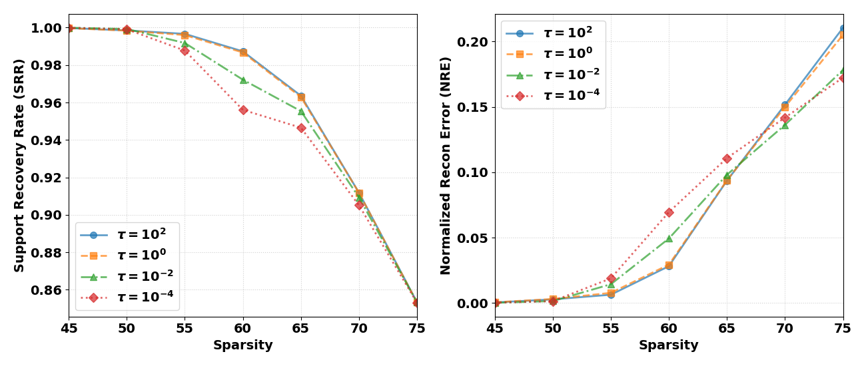
(a) | (b)
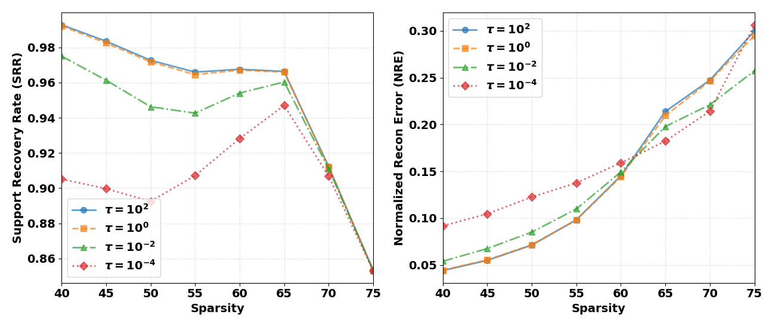
(c) | (d)
Fig 4.1 Reconstruction performance (SRR and NRE) of the OMP algorithm under varying hyperparameter. (a)-(b) Noise-free scenario; (c)-(d) Scenario with 30 dB Gaussian noise.
From Fig. 4.1(a) and (b), it can be observed that the SRR experiences a sharp decline at $k = 60$ when $τ$ is set to ${10}^{-2}$ and ${10}^{-4}$, whereas other values of $τ$ exhibit a more gradual decrease. The NRE curve shows the cost of this parameter choice. When the sparsity level exceeds the measurement dimension (i.e., $k > m$, with $m = 64$), the NRE of τ of ${10}^{0}$ and ${10}^{2}$ is about 0.03 higher than the other settings at $k=75$.
Under 30 dB noise (Fig. 4.1(c) and (d)), the advantage of $τ$ in the range of ${10}^{0}$ to ${10}^{2}$ is further reinforced. The SRR difference between parameter settings becomes clearer after noise is added. At $k = 50$, the largest SRR difference between the tested $τ$ values are about 0.08.
The second experiment tests the effect of the learning length $l$, using SRR and NRE as the evaluation measures. The tested learning length ranged from $l=2$ to $l=70$.
Fig. 4.2 shows that the reconstruction result changes noticeably when only a small number of prior samples are used. The performance gradually stabilizes once the learning length exceeds 60. However, a noticeable degradation in SRR occurs when $l$ increases from 4 to 5, where SRR decreases from 0.985 to 0.96. A corresponding inverse trend can also be observed in the NRE curve.
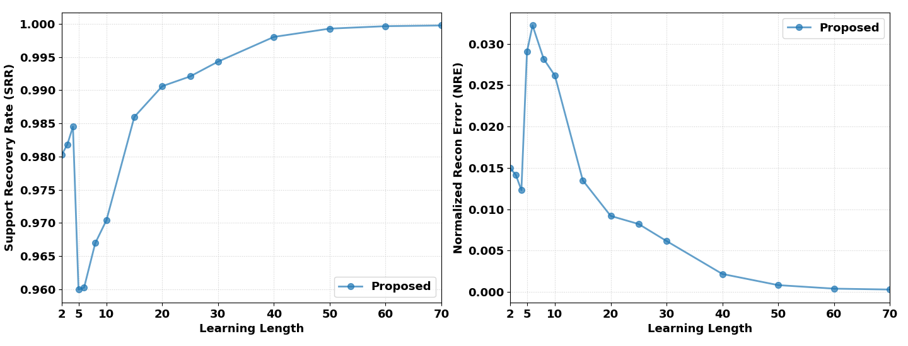
Fig 4.2 Performance of the OMP algorithm using the sensing matrix designed by the proposed method with different values of learning length from 2 to 70.

4.2.2 Performance Comparison
Fig. 4.3–4.6 compare standard OMP with gaussian random matrix, the Schnass method and the proposed method under changes in sparsity, measurement length, noise level and running time.
First, Fig. 4.3 analyzes how the sparsity level $k$ (from 5 to 75) affects reconstruction performance. As sparsity increases, the proposed method delays the drop in SRR and makes the decrease more gradual. Specifically, the SRR of the reference method drops quickly when the sparsity $k$ increases by about 5. In contrast, the proposed method requires an increase of about 20 in sparsity $k$ to cause a decrease in SRR of 0.2. Similarly, the incremental rate of the proposed method in NRE is much slower than that of other methods, and the starting point is far behind others.
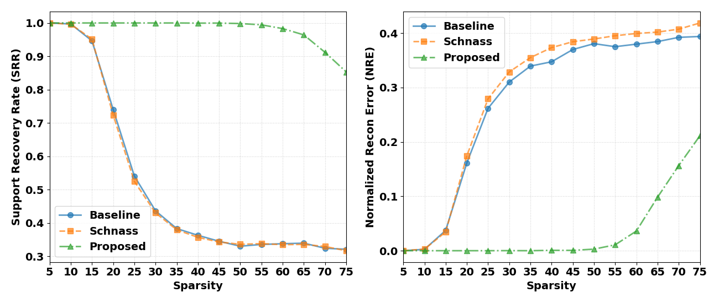
Fig. 4.3 Performance of the OMP algorithm using various sensing matrices. The sparsity level ranges from 5 to 75.
Second, Fig. 4.4 illustrates the effect of the measurement vector length $m$ (from 10 to 120) on recovery performance. The NRE of the proposed method is consistently lower than that of the benchmark method and the Schnass method throughout the entire testing range. This is especially clear when the value of m is between 20 and 90. It shows a clear advantage. The proposed method also has a steeper improvement trend, quicker SRR growth, and a faster decline in NRE. When $m=40$, the proposed method achieves perfect signal recovery, while both the benchmark method and the Schnass method need $m=120$ to reach similar performance.
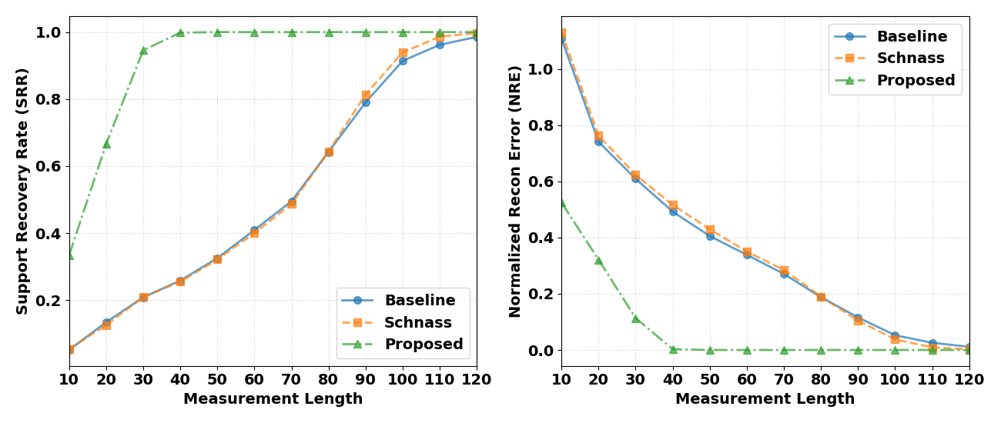
Fig. 4.4 Performance of the OMP algorithm using various sensing matrices. The measurement length ranges from 10 to 120.
To evaluate the algorithm's robustness to noise, Fig. 4.5 shows the reconstruction results at different SNR levels, ranging from 5 dB to 40 dB. The proposed method always maintains an SRR above 0.9 across this range, which is about 0.6 higher than that of the benchmark method. The NRE gap is smaller, around 0.4.
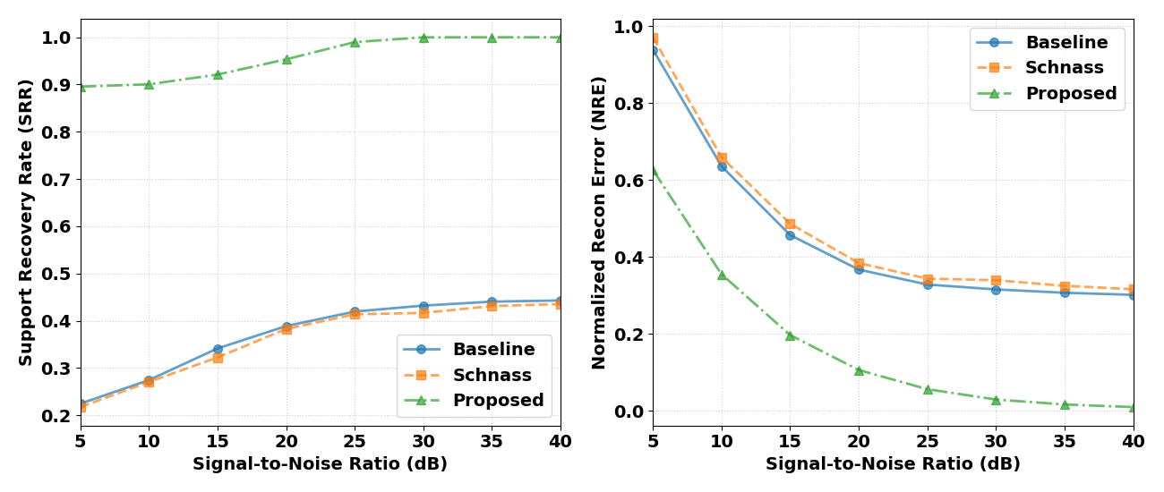
Fig. 4.5 Performance of the OMP algorithm using various sensing matrices. The SNR ranges from 5 dB to 40 dB.
Finally, Fig. 4.6 shows the proposed method's performance in terms of computational efficiency when the parameter setting follow section 4.1.1 except $m=32$ and $k=20$. The average time per execution increases by only 0.4 ms compared to standard OMP (0.73 ms). Moreover, it is much more efficient than the iterative alternating projection method suggested by Schnass (15.37 ms). These results show that the proposed method greatly improves reconstruction accuracy while the increase in computational overhead is minimal.
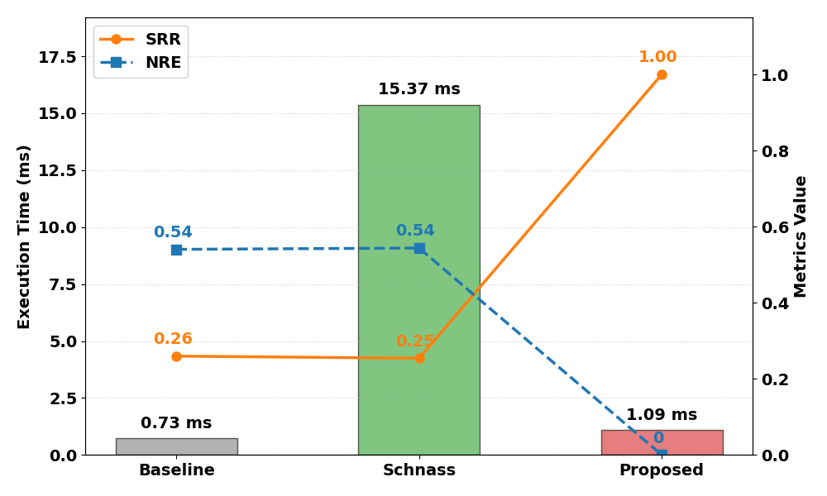
Fig. 4.6 Performance of the OMP algorithm using various sensing matrices. Average execution time with a learning length of 100.

4.3 Evaluation on MNIST Dataset

4.3.1 Experiment Setup
The MNIST handwritten digit dataset was used as an intermediate image-based test before applying the method to dynamic MRI data. Compared with medical images, MNIST images are much smaller and structurally simpler, with each sample having a resolution of $28×28$pixels. This makes the dataset suitable for observing whether the proposed sensing matrix can improve OMP reconstruction in a controlled image reconstruction task.
Each image is vectorized to a signal with a length of $n=784$, and sparsity is promoted through discrete cosine transform (DCT) domain transformation, with the sparsity set to $k=30$. The measured length is set to $m=156$.
For each experiment, 100 training images were randomly selected to construct the prior signal matrix and learn the sensing matrix $Ψ$. The test image was compressed using a Gaussian random measurement matrix, producing a measurement vector of length 156. OMP was then applied for sparse recovery, and the reconstructed image was obtained through inverse DCT.
Regarding the dataset configuration, we used 5000 MNIST images as the subset. To ensure statistical reliability across multiple experiments, we dynamically extracted 100 images for sensing matrix learning in each experiment. Recovery performance is evaluated using 500 independent images.
The quantitative metric was peak signal-to-noise ratio (PSNR), which measures the similarity between the reconstructed image and the original image. A higher PSNR indicates better reconstruction quality.

4.3.2 Experiment Results
To examine why the proposed method affects OMP reconstruction, the cross-correlation structure between the sensing matrix and the measurement matrix was first analyzed. The cross-Gram matrix is defined as: $G=Ψ^{T}Φ$, where each element $G_{i,j}$ represents the inner product between the $i$-th column of the sensing matrix and the $j$-th column of the measurement matrix. In an ideal case, $G$ should be close to an identity matrix. The diagonal elements correspond to the response of each atom to itself, while the off-diagonal elements indicate interference from other atoms.
Based on this matrix, the Global Mean Interference was calculated by averaging the absolute values of the off-diagonal elements. This value provides a simple numerical measure of the overall interference level during atom selection. As shown in Fig. 4.7, the benchmark method $\left(Ψ = Φ\right)$produces a relatively scattered Gram matrix, with a global mean interference of 0.064. The Schnass method reduces this value to 0.056 by suppressing cross-correlation through mathematical optimisation.
The proposed method gives a slightly lower global mean interference of 0.055. Although this improvement over the Schnass method is small in terms of the average value, the heatmap shows a different structure. Instead of only reducing the overall magnitude of interference, the proposed matrix forms a more organized stripe-like pattern. This suggests that the learned sensing matrix does not simply minimize all correlations uniformly, but reshapes the interference according to the structure learned from the MNIST training samples.
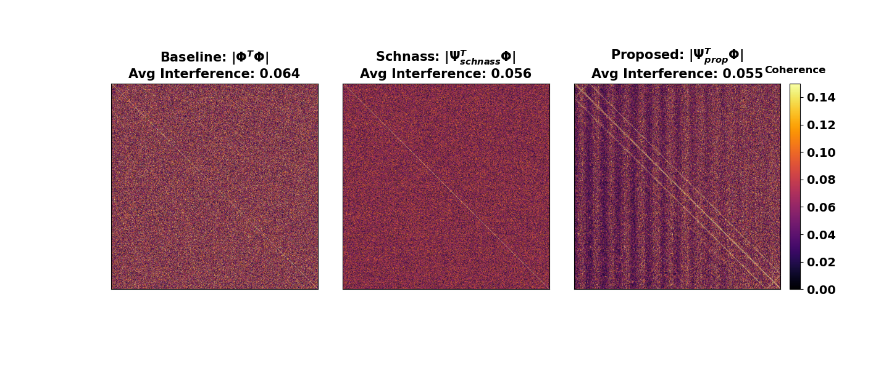
Fig. 4.7 The heatmaps of the Gram matrix when the measurement is 156 and the sparsity level is 30, with a learning length size of 100.
But this difference becomes more pronounced. The probability density histogram of the effective interference values is shown in the Fig. 4.8. Effective interference refers to the inner product response between the true supporting atom and the remaining candidate atom during the sparse recovery process, that is, the actual interference that directly affects the selection of greedy atoms. The effective interference values should ideally be close to zero, because large values may cause OMP to select incorrect atoms. As shown in Fig. 4.8, the benchmark method has a long-tailed distribution, with a maximum value of 0.5148 and an average value of 0.1107. This indicates that some non-support atoms still have strong correlation responses. The Schnass method reduces these values to 0.3174 and 0.1000, respectively, but a noticeable peak remains around 0.15.
By comparison, the proposed method reduces the average effective interference to 0.0580. This value is close to the global mean interference in Fig. 4.7, with a difference of only 0.003. More importantly, high-interference outliers are reduced, suggesting that the learned sensing matrix provides a cleaner matching environment for OMP atom selection.
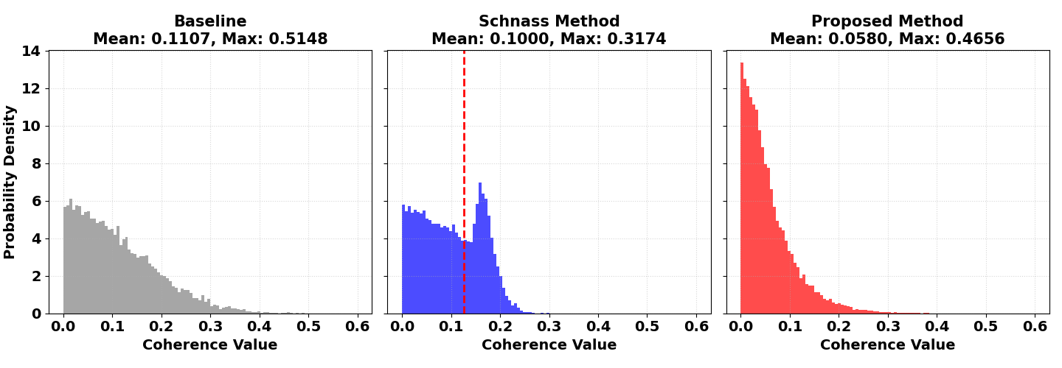
Fig. 4.8 Probability density histograms of effective interference correlations, with measurement dimension is 156, sparsity level is 30 and learning set size of 100.
Based on this statistical advantage, we can see its impact on reconstruction image. The experimental results are shown in Fig. 4.9, indicating that our proposed method performs better in terms of reconstruction quality. Specifically, it improves PSNR by 1.48 dB compared to the benchmark method and 2.24 dB compared to the Schnass method. In other words, the reconstructed image reveals sharper structural details.
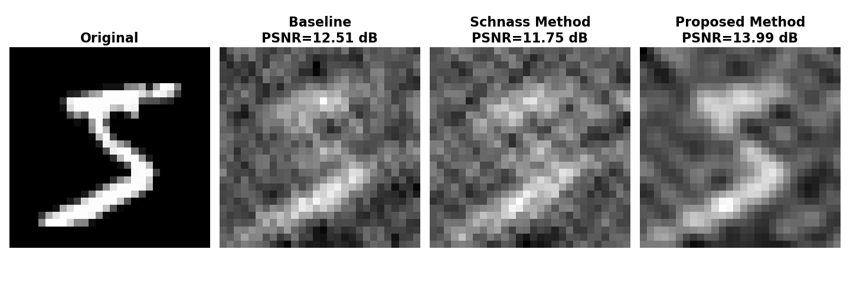
Fig. 4.9 Visual reconstruction comparison on the MNIST dataset when measurement length is 156 and sparsity level is 30, with a learning set size of 100.
While the above results validate the effectiveness of our method at a fixed setting, in order to fully evaluate its robustness, we also need to examine its performance under different problem conditions. Therefore, the next experiment investigated the effect of compression ratio (CR) and sparsity level on reconstruction performance. The compression ratio is defined as $CR =m/n$. Fig. 4.10(a) shows the effect when the compression ratio changes from 0.1 to 0.6, with the sparsity fixed at $k=50$. The proposed method shows its main advantage when the compression ratio is between 0.1 and 0.5 obtaining higher PSNR than the baseline methods. This result is consistent with the purpose of the learned sensing matrix, because the benefit of improved atom selection becomes more visible when the available measurements are limited. When the compression ratio increases to 0.6, the benchmark method begins to achieve better performance. One possible reason is that, with more measurements available, the original Gaussian matrix already provides sufficient information, while the learned sensing matrix may introduce a slight bias from the training samples.
Fig. 4.10(b) further compares the reconstruction performance under different sparsity levels, with the sampling ratio fixed at 0.2. The proposed method performs well over a wide middle range of sparsity, especially from $k=10$ to $k=130$. The largest improvement appears around $k=45$, where the PSNR gain is approximately 3.5 dB. However, when the sparsity level increases to $k=150$, the advantage becomes weaker. This indicates that the learned sensing matrix is most useful when the sparse representation still has a clear dominant structure. If too many coefficients are retained, the support becomes less selective, and the prior learned from training samples may no longer provide a strong advantage.
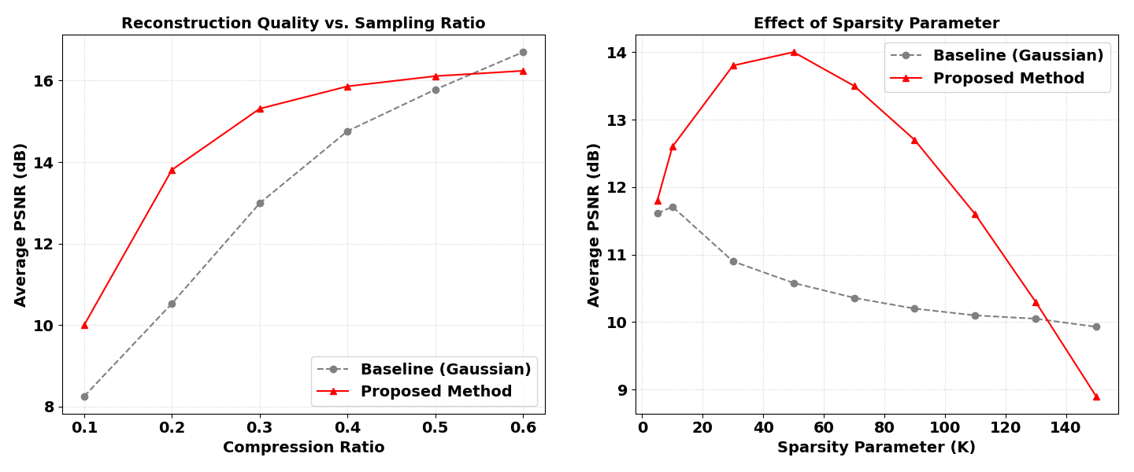
(a) | (b)
Fig. 4.10 Performance of the OMP algorithm (a) using various sampling ratio ranging from 0.1 to 0.6 with sparsity of 50, (b) using various sparsity level ranging from 5 to 150 with sampling ratio is 0.2.

4.3.3 Correlation Between SRR and NRE
To further examine the reconstruction behavior, the relationship between SRR and NRE was analyzed using scatter plots. Fig. 4.11 reports the averaged results from 100 repeated experiments. In these experiments, the sparsity level varied from $0.02n$ to $0.25n$, and the measurement dimension varied from $0.1n$ to $0.8n$. The learning length was fixed at $l=100$, and the regularisation parameter was set to $τ=1$. Each point in the figure represents one specific combination of $k$ and $m$.
The scatter distribution shows a clear relationship between support recovery and reconstruction error. For the benchmark method, the points are more widely spread, which means that similar SRR values may still lead to noticeably different NRE values. In comparison, the points of the proposed method are more concentrated in the region with higher SRR and lower NRE. This indicates that the learned sensing matrix helps OMP identify the correct support more consistently under most parameter settings.
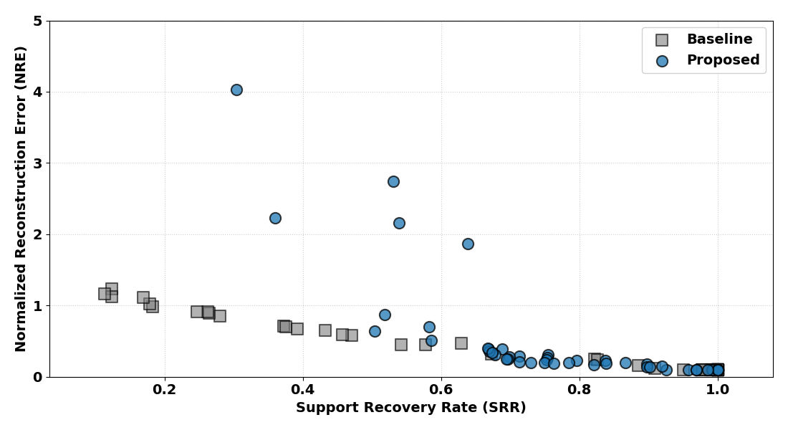
Fig. 4.11. Correlation analysis between SRR and NRE under different sparsity levels and measurement dimensions, with learning length of 100.
However, Fig. 4.11 also shows a limitation of the proposed method. When SRR falls below 0.6, the NRE of the proposed method can increase sharply and may reach about 4, while the benchmark method degrades more gradually, with its NRE peak close to 1.2. This result suggests that the proposed method improves average reconstruction performance, but it may be less stable in extreme cases. A possible explanation is that the learned sensing matrix is biased towards the dominant structures in the training samples. If a test image contains support components outside this learned pattern, OMP may select several incorrect atoms at an early stage. Since the following least-squares step is based on this wrong support set, the final reconstruction error can become much larger.

4.4 Evaluation on Real Dynamic MRI

4.4.1 Experiment Setup
To evaluate the applicability of our method in real-world clinical scenarios, we used a dynamic brain MRI dataset. The dataset contains 180 continuous images with a high spatial resolution of $256×256$ pixels per frame. Each MRI frame was divided into non-overlapping $32×32$ patches before reconstruction. This block-based setting reduces the dimension of each reconstruction problem rather than from the whole frame at once.
For each patch, the original signal dimension was $n=1024$. The number of compressed measurements was set to $m=204$, and the sparsity level was limited to $k=64$. The DCT transform was used as the sparse representation, following the same setting as the MNIST experiment. After OMP recovered the sparse coefficients, inverse DCT was applied to obtain the reconstructed image patch.
The dynamic MRI sequence contains clear structural changes across frames. In particular, the first 25 frames and the last 80 frames show stronger variations because of slice transition and changing anatomical boundaries. These changes are not always obvious when viewing the full image, but they become more significant at the patch level. Some local structures appear, move or disappear across neighboring frames. This makes the dataset suitable for testing whether the proposed prior-based sensing matrix can remain stable when the sparse support changes over time.

4.4.2 Prior Length Analysis
The length of the historical prior was tested before the final reconstruction experiment. Different numbers of previous frames were included in the learning window, and the corresponding reconstruction performance is shown in Fig. 4.12. The result indicates that using more historical frames improves reconstruction at the beginning, but the improvement becomes limited after about 10 frames. Based on this result, the temporal window was set to 10 previous frames in the following experiments.
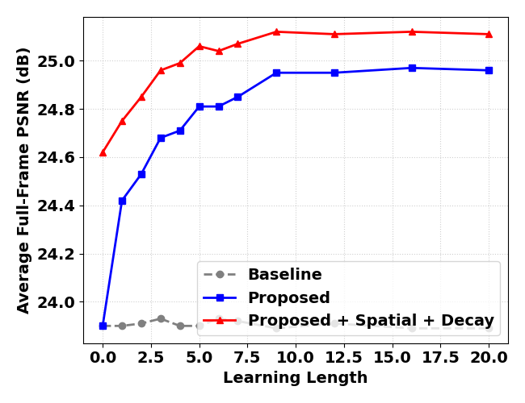
Fig. 4.12 Performance of the OMP algorithm using the sensing matrix designed by the proposed method with different values of learning length.

4.4.3 Comparison Baselines
In addition to the previously considered Gaussian random matrix and the Schnass method, two further baselines are included for comparison. A structured prior-based dynamic optimization method proposed by Li et al. (2017) was also included for comparison. This method uses historical information to update the sampling matrix and improve reconstruction quality. In addition, Modified-CS was selected as another baseline because it uses support information from previous frames and performs recovery through Basis Pursuit (Vaswani and Lu, 2010).

4.4.4 Reconstruction Results
The reconstruction results for the dynamic MRI sequence are shown in Fig. 4.13. At the beginning of the sequence, some prior-based methods show visible fluctuations because only a limited number of historical frames are available. This can be regarded as a short warm-up stage, where the prior information has not yet become stable.
The proposed method is less affected by this problem. Since neighboring patches in the same frame are included in the prior matrix, the algorithm can still use local spatial information even when the temporal history is short. As a result, the reconstruction quality remains relatively stable from the early frames.
Across the main fluctuation intervals in Fig. 4.13, the proposed method gives about 1 dB higher PSNR than the benchmark OMP method. This improvement is related to two factors. First, neighboring patches provide local structural information for atom selection. Second, the exponential decay mechanism reduces the influence of older frames, which may no longer match the current anatomical structure. These two mechanisms help the learned sensing matrix provide a more reliable matching process for OMP during dynamic reconstruction.
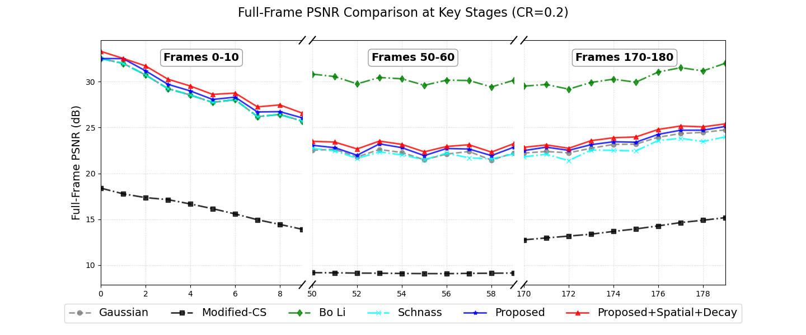
Fig. 4.13 Performance of the OMP algorithm on Real MRI sequences, with CR is 0.2 and the learning length is 10$.$
Frame 50 was extracted from the MRI series to demonstrate the image reconstruction quality. It can be seen from Fig. 4.14 that most of the improvement is on the boundary of the brain (max: 0.61dB), although this is accompanied by some loss of detail.
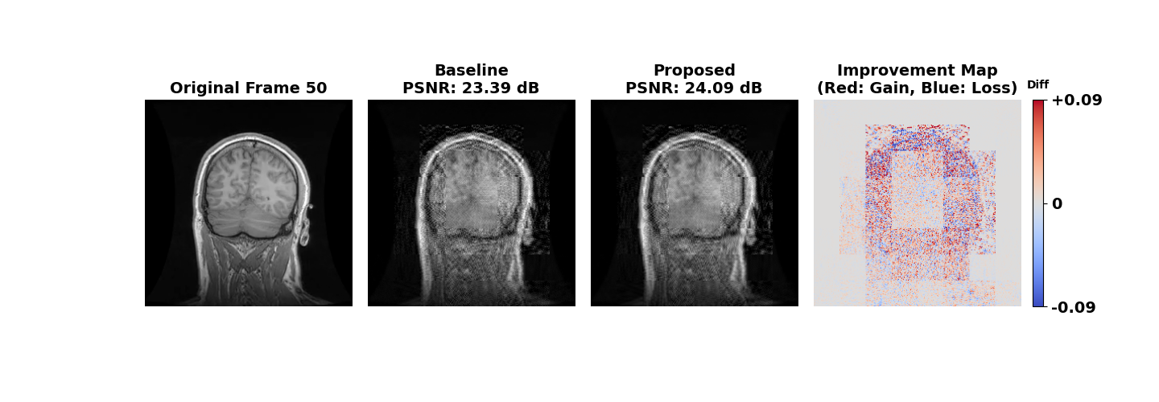
Fig. 4.14 Performance comparison of the OMP algorithm on frame 50 of the Real MRI sequences, with CR is 0.2 and the learning length is 10$.$

V Conclusion
This thesis studied the sensing matrix design problem for OMP-based compressive sensing reconstruction. The main motivation was that relies on generalized sensing matrix to help atom selection in each iteration. However, these generalized sensing matrices are unable to effectively capture the inherent structural patterns of the data. Additionally, the existing methods for optimizing sensing matrices often face issues such as significant computational overhead. Therefore, a data-driven sensing matrix learning method was proposed for this purpose. The method uses prior sparse signals to learn an equivalent sensing matrix, which is then applied only in the OMP matching step.
The theoretical part of the thesis derived a closed-form solution for the learned sensing matrix. To reduce the computational burden of direct matrix inversion, the push-through identity was used to move the inverse operation to a lower-dimensional matrix. Under the tested setting, this reduces the main computational term from $O\left(mnl\right)$to $O(ml^{2})$. For dynamic MRI, a spatiotemporal prior was also introduced. Recent historical patches were weighted more strongly through exponential decay, and neighbouring patches were added to improve local structural consistency. For the power-law attenuated sparse signals, the proposed method shows clear improvement over the Schnass method in most test cases. The SRR is increased by about 0.5, while the NRE is reduced by approximately 0.4. At the same time, the additional computational cost remains small. Compared with standard OMP using a Gaussian random matrix, the average running time increases by only about 0.4 ms. In the real dynamic brain MRI experiment, the proposed framework also improves the mean PSNR by around 1 dB compared with the baseline method.
However, the results also show several limitations. First, the method is not always stable under extreme reconstruction conditions. When the SRR drops below 0.6, the NRE may become higher than that of the Gaussian random baseline. This suggests that once the support set is incorrectly estimated, the learned sensing matrix may amplify the reconstruction error rather than reduce it. Second, the method depends on the quality of the prior data. Before the historical window becomes stable, changing the learning length can lead to a PSNR difference of nearly 1 dB. This indicates that the correlation between the prior samples and the current target signal plays an important role in reconstruction performance.
Future work should therefore focus on improving robustness and prior selection. One possible direction is to introduce a controlled random component or an additional regularization term into the sensing matrix learning objective, so that the matrix is less biased towards a narrow group of training samples. Another direction is to design an adaptive prior-selection strategy. Instead of using historical frames directly, future methods could select prior patches according to their similarity to the current image block. This may reduce the influence of outdated or weakly related structures in dynamic MRI sequences.
Overall, the proposed framework provides a low-complexity way to introduce prior information into OMP reconstruction. It improves atom selection and reconstruction quality in most tested settings, while keeping the physical measurement matrix unchanged. This makes the method suitable for accelerated MRI reconstruction scenarios where both reconstruction accuracy and computational efficiency are important.
窗体顶端
窗体底端

Reference
Ahishakiye, E. et al. (2021) 'A survey on deep learning in medical image reconstruction', Intelligent Medicine, 01(03), pp. 118–127. Available at: https://doi.org/10.1016/j.imed.2021.03.003.
Candes, E.J., Romberg, J. and Tao, T. (2006) 'Robust uncertainty principles: Exact signal reconstruction from highly incomplete frequency information', IEEE Transactions on Information Theory, 52(2), pp. 489–509. Available at: https://doi.org/10.1109/TIT.2005.862083.
Crespo Marques, E. et al. (2019) 'A review of sparse recovery algorithms', IEEE Access, 7, pp. 1300–1322. Available at: https://doi.org/10.1109/ACCESS.2018.2886471.
Do, T.T. et al. (2012) 'Fast and efficient compressive sensing using structurally random matrices', IEEE Transactions on Signal Processing, 60(1), pp. 139–154. Available at: https://doi.org/10.1109/TSP.2011.2170977.
Donoho, D.L. (2006) 'Compressed sensing', IEEE Transactions on Information Theory, 52(4), pp. 1289–1306. Available at: https://doi.org/10.1109/TIT.2006.871582.
Donoho, D.L.et al. (2012) Sparse solution of underdetermined systems of linear equations by stagewise orthogonal matching pursuit. IEEE Transactions on Information Theory, 58(2), pp.1094-1121. Available at: https://doi.org/10.1109/TIT.2011.2173241.
Eftekhari, A. et al. (2015) 'The restricted isometry property for random block diagonal matrices', Applied and Computational Harmonic Analysis, 38(1), pp. 1–31. Available at: https://doi.org/10.1016/j.acha.2014.02.001.
Elad, M. (2007) 'Optimized projections for compressed sensing', IEEE Transactions on Signal Processing, 55(12), pp. 5695–5702. Available at: https://doi.org/10.1109/TSP.2007.900760.
Emadi, M., Miandji, E. and Unger, J. (2018) 'A performance guarantee for orthogonal matching pursuit using mutual coherence', Circuits, Systems, and Signal Processing, 37(4), pp. 1562–1574. Available at: https://doi.org/10.1007/s00034-017-0602-x.
Hamilton, J., Franson, D. and Seiberlich, N. (2017) ‘Recent advances in parallel imaging for MRI’, Progress in Nuclear Magnetic Resonance Spectroscopy, 101, pp. 71–95. Available at: https://doi.org/10.1016/j.pnmrs.2017.04.002.
Huang, A. et al. (2011) 'A re-weighted algorithm for designing data dependent sensing dictionary', International Journal of the Physical Sciences, 6(3), pp. 386–390. Available at: https://doi.org/10.5897/IJPS11.071.
Jaspan, O.N., Fleysher, R. and Lipton, M.L. (2015) 'Compressed sensing MRI: A review of the clinical literature', British Journal of Radiology, 88(1056), article 20150487. Available at: https://doi.org/10.1259/bjr.20150487.
Jiang, Q. et al. (2020) 'Design of compressed sensing system with probability-based prior information', IEEE Transactions on Multimedia, 22(3), pp. 594–609. Available at: https://doi.org/10.1109/TMM.2019.2931400.
Joseph, P.M. (1998) 'Sampling errors in projection reconstruction MRI', Magnetic Resonance in Medicine, 40(3), pp. 460–466. Available at: https://doi.org/10.1002/mrm.1910400317.
Jung, H. et al. (2009) 'k-t FOCUSS: A general compressed sensing framework for high resolution dynamic MRI', Magnetic Resonance in Medicine, 61(1), pp. 103–116. Available at: https://doi.org/10.1002/mrm.21757.
Kalakrishnan, M. et al. (2011) 'STOMP: Stochastic trajectory optimization for motion planning', IEEE International Conference on Robotics and Automation, pp. 4569–4574. Available at: https://doi.org/10.1109/ICRA.2011.5980280.
Ko, T. and Li, X. (2022) 'A local convergence theory for the stochastic gradient descent method in non-convex optimization with non-isolated local minima' [Version 1 May 2022]. Available at: https://doi.org/10.48550/arXiv.2203.10973.
Krahmer, F. and Rauhut, H. (2014) 'Structured random measurements in signal processing', GAMM-Mitteilungen, 37(2), pp. 217–238. Available at: https://doi.org/10.1002/gamm.201410010.
Kulkarni, A. and Mohsenin, T. (2017) 'Low overhead architectures for OMP compressive sensing reconstruction algorithm', IEEE Transactions on Circuits and Systems, 64(6), pp. 1468–1480. Available at: https://doi.org/10.1109/TCSI.2017.2648854.
Li, B. et al. (2017) 'Projection matrix design using prior information in compressive sensing', Signal Processing, 135, pp. 36–47. Available at: https://doi.org/10.1016/j.sigpro.2016.11.024.
Li, L. et al. (2020) 'Overview of compressed sensing: Sensing model, reconstruction algorithm, and its applications', Applied Sciences, 10(17), article 5909. Available at: https://doi.org/10.3390/app10175909.
Lustig, M. et al. (2008) 'Compressed sensing MRI', IEEE Signal Processing Magazine, 25(2), pp. 72–82. Available at: https://doi.org/10.1109/MSP.2007.914728.
Lustig, M., Donoho, D. and Pauly, J.M. (2007) 'Sparse MRI: The application of compressed sensing for rapid MR imaging', Magnetic Resonance in Medicine, 58(6), pp. 1182–1195. Available at: https://doi.org/10.1002/mrm.21391.
Ma, Z. et al. (2023) 'Performance assessment and exhaustive listing of 500+ nature-inspired metaheuristic algorithms', Swarm and Evolutionary Computation, 77, article. 101248. Available at: https://doi.org/10.1016/j.swevo.2023.101248.
Mallat, S.G. and Zhang, Z. (1993) 'Matching pursuits with time-frequency dictionaries', IEEE Transactions on Signal Processing, 41(12), pp. 3397–3415. Available at: https://doi.org/10.1109/78.258082.
Meng, Z. et al. (2021) 'A comparative study of metaheuristic algorithms for reliability-based design optimization problems', Archives of Computational Methods in Engineering, 28(3), pp. 1853–1869. Available at: https://doi.org/10.1007/s11831-020-09443-z.
Mohades, M.M., Mohades, H. and Zamanian, S.F. (2025) 'Binary deterministic sensing matrix construction using manifold optimization' [Version 1 Feb 2025]. Available at: https://doi.org/10.48550/arXiv.2502.13492.
Naidu, R.R., Jampana, P. and Sastry, C.S. (2016) 'Deterministic compressed sensing matrices: Construction via Euler squares and applications', IEEE Transactions on Signal Processing, 64(14), pp. 3566–3575. Available at: https://doi.org/10.1109/TSP.2016.2550020.
Needell, D. and Tropp, J.A. (2009) 'CoSaMP: Iterative signal recovery from incomplete and inaccurate samples', Applied and Computational Harmonic Analysis, 26(3), pp. 301–321. Available at: https://doi.org/10.1016/j.acha.2008.07.002.
Parkale, Y.V. and Nalbalwar, S.L. (2021) 'Application of compressed sensing for image compression based on optimized Toeplitz sensing matrices', EURASIP Journal on Advances in Signal Processing, 2021, 70. Available at: https://doi.org/10.1186/s13634-021-00743-5.
Pati, Y.C., Rezaiifar, R. and Krishnaprasad, P.S. (1993) 'Orthogonal matching pursuit: Recursive function approximation with applications to wavelet decomposition', 27th Asilomar Conference on Signals, Systems and Computers, pp. 40–44 vol.1. Available at: https://doi.org/10.1109/ACSSC.1993.342465.
Petersen, K.B. and Pedersen, M.S. (2012) 'The matrix cookbook'.
Qiu, J. et al. (2023) 'Large AI models in health informatics: Applications, challenges, and the future', IEEE Journal of Biomedical and Health Informatics, 27(12), pp. 6074–6087. Available at: https://doi.org/10.1109/JBHI.2023.3316750.
Rabah, H. et al. (2015) 'FPGA implementation of orthogonal matching pursuit for compressive sensing reconstruction', IEEE Transactions on Very Large Scale Integration (VLSI) Systems, 23(10), pp. 2209–2220. Available at: https://doi.org/10.1109/TVLSI.2014.2358716.
Ravazzi, C., Fosson, S., Bianchi, T. et al. (2018) 'Sparsity estimation from compressive projections via sparse random matrices ', EURASIP Journal on Advances in Signal Processing, 2018, 56. doi:10.1186/s13634-018-0578-0.
Ronneberger, O., Fischer, P. and Brox, T. (2015) 'U-Net: Convolutional networks for biomedical image segmentation', Medical Image Computing and Computer-Assisted Intervention – MICCAI 2015, Munich (Germany), 5–9 October. Springer International Publishing, pp. 234–241. Available at: https://doi.org/10.1007/978-3-319-24574-4_28
Safari, M. et al. (2026) 'Advancing MRI reconstruction: A systematic review of deep learning and compressed sensing integration', Biomedical Signal Processing and Control, 111, article 108291. Available at: https://doi.org/10.1016/j.bspc.2025.108291.
Schnass, K. and Vandergheynst, P. (2008) 'Dictionary preconditioning for greedy algorithms', IEEE Transactions on Signal Processing, 56(5), pp. 1994–2002. Available at: https://doi.org/10.1109/TSP.2007.911494.
Shahbazi, H., Taban, M.R. and Abouei, J. (2019) 'A new approach to design sensing matrix based on the sparsity constant with applications to computed tomography', IEEE Access, 7, pp. 175396–175410. Available at: https://doi.org/10.1109/ACCESS.2019.2957479.
Shen, D., Wu, G. and Suk, H.-I. (2017) 'Deep learning in medical image analysis', Annual Review of Biomedical Engineering, 19, pp. 221–248. Available at: https://doi.org/10.1146/annurev-bioeng-071516-044442.
Tolouee, A., Alirezaie, J. and Babyn, P. (2015) 'Compressed sensing reconstruction of cardiac cine MRI using golden angle spiral trajectories', Journal of Magnetic Resonance, 260, pp. 10–19. Available at: https://doi.org/10.1016/j.jmr.2015.09.003.
Tropp, J.A. (2004) 'Greed is good: Algorithmic results for sparse approximation', IEEE Transactions on Information Theory, 50(10), pp. 2231–2242. Available at: https://doi.org/10.1109/TIT.2004.834793.
Tropp, J.A. and Gilbert, A.C. (2007) 'Signal recovery from random measurements via orthogonal matching pursuit', IEEE Transactions on Information Theory, 53(12), pp. 4655–4666. Available at: https://doi.org/10.1109/TIT.2007.909108.
Yaghoobi, M., Wu, D. and Davies, M.E. (2015) 'Fast non-negative orthogonal matching pursuit', IEEE Signal Processing Letters, 22(9), pp. 1229–1233. Available at: https://doi.org/10.1109/LSP.2015.2393637.
Yang, Y. et al. (2016) 'Deep ADMM-Net for compressive sensing MRI', Advances in Neural Information Processing Systems, Barcelona (Spain), 5–10 December. Curran Associates, Inc. Available at: https://proceedings.neurips.cc/paper_files/paper/2016/hash/1679091c5a880faf6fb5e6087eb1b2dc-Abstract.html (Accessed: 28 February 2026).
Yi, R. et al. (2025) 'Methods of sparse measurement matrix optimization for compressed sensing', IET Signal Processing, 2025(1), article 1233853. Available at: https://doi.org/10.1049/sil2/1233853.
Zhang, J. and Ghanem, B. (2018) 'ISTA-Net: Interpretable optimization-inspired deep network for image compressive sensing', Proceedings of the IEEE Conference on Computer Vision and Pattern Recognition, Salt Lake City (USA), 18–22 June. IEEE, pp. 1828–1837. Available at: https://openaccess.thecvf.com/content_cvpr_2018/html/Zhang_ISTA-Net_Interpretable_Optimization-Inspired_CVPR_2018_paper.html (Accessed: 14 March 2026).
Zhang, Z. et al. (2015) 'A survey of sparse representation: Algorithms and applications', IEEE Access, 3, pp. 490–530. Available at: https://doi.org/10.1109/ACCESS.2015.2430359.
Zhao, J. et al. (2015) 'Coherence-based analysis of modified orthogonal matching pursuit using sensing dictionary', IET Signal Processing, 9(3), pp. 218–225. Available at: https://doi.org/10.1049/iet-spr.2014.0164.
Zhao, Y.B. and Luo, Z.Q. (2023) ‘Dynamic orthogonal matching pursuit for sparse data reconstruction’, IEEE Open Journal of Signal Processing, 4, pp. 242–256. Available at: https://doi:10.1109/OJSP.2023.3247301.

致谢
兴安岭南，松花江畔。直到最近，我才逐渐意识到，离开哈尔滨的日子已经不再遥远。于是，我开始更加用力地去感受这座城市——在最后的时光里，尽可能地填满关于它的记忆。回想初来乍到之时，我还戴着口罩，在陌生与不安中慢慢适应北方的生活；第一次见到漫天大雪，第一次领略辽阔的东北大地，甚至连说话的语调，也在不知不觉中染上了些许东北的味道。
这一路的收获与改变，离不开许多人的帮助与陪伴。首先，我要衷心感谢我的导师李波老师和Thomas Blumensath老师。李老师始终给予我耐心而细致的指导，在我遇到困难与困惑时，总能以清晰的思路与关键性的点拨让我豁然开朗。Thomas Blumensath教授对论文提出的宝贵意见，也让我在学术表达与逻辑结构方面有了更深的理解与提升。
同时，我要感谢联合学院的培养。在这里，我不仅夯实了专业基础，也逐渐学会以更加严谨与批判性的方式思考工程问题。感谢所有任课教师的辛勤付出，是你们为我打下了坚实的数理基础与工程素养。我也要感谢我的同窗与挚友。那些在烧烤店的欢笑、在寝室深夜的畅谈，将成为我记忆中最温暖的片段。正是你们的陪伴，让原本平凡的日子变得闪闪发光。
最后，我要深深感谢我的父母与家人。二十余年的养育与支持，让我能够心无旁骛地追逐自己的理想。你们始终是我最坚实的后盾，你们的理解与期望，是我不断前行的动力源泉。
谨以此文，献给所有在我成长道路上给予帮助与支持的人。
赵天航
2026年5月于哈尔滨工程大学

Acknowledgement
Only recently have I realized that my time in Harbin is coming to an end. In the remaining days, I’ve sought to immerse myself in the city, collecting memories of the places and moments that shaped my growth. I still remember arriving here, wearing a mask, adjusting to life in the unfamiliar north. The first snowfall, the vast northeastern landscape, and how my accent gradually picked up traces of the local dialect—these small moments have become the essence of my journey over the past four years.
None of this would have been possible without the support of many people. I am deeply grateful to my supervisors, Professor Bo Li and Professor Thomas Blumensath, whose guidance and insightful advice helped me overcome challenges and improve my work. Their dedication and rigor have been invaluable lessons in my academic journey.
I also thank the Joint Institute for providing a nurturing environment that helped me build a solid foundation in my field. The lecturers’ hard work has been essential in developing my mathematical and engineering skills.
I am equally thankful to my classmates and friends. The laughter shared over late-night conversations and gatherings at barbecue restaurants will forever be cherished. Your companionship made even ordinary days special.
Finally, my deepest gratitude goes to my parents and family. Their unwavering support has been the driving force behind my efforts, allowing me to pursue my goals with confidence and focus.
This thesis is dedicated to everyone who has supported and walked with me along this journey.
Tianhang Zhao
May 2026
Harbin Engineering University

